Warden Parish Council
Chairman: Mr S Heminsley
Clerk: Claire Miller
14 Addycombe Close
Rothbury
Morpeth
NE65 7QF
Telephone: 01669 621565
Dear Councillor
You are summonsed to attend an ordinary meeting of Warden Parish Council which will take place in Newbrough Town Hall on Monday 2nd September 2019 commencing at 7.00pm. A public session will precede the Council Meeting
AGENDA
2019/76 Apologies for Absence
2019/77 Declaration of Interests
2019/78 Minutes of previous meeting held on Monday 1st July 2019
2019/79 Matters arising from previous meeting held on Monday 1st July 2019 (not on agenda)
2019/80 Allotments
2019/81 Litter pick
2019/82 Roads/footpaths
2019/83 Correspondence: CPRE – newsletter; Northumberland Age UK; Northumberland County Council – Waste leaflets & stickers; Northumberland County Council – notice of 6th Annual Town & Parish Council Conference

2019/84 Planning
2019/84/01 Planning Applications received:
2019/84/02 Notice of Planning application being approved:
- 19/01220/LBC: Martlet Fourstones, Listed Building Consent, replacement of 2 rotten window frames and 2 frames to match, repair of UPVC window units and hinges
- 19/01571/FUL: Land North West of Nether, erection of building to enclose existing outdoor riding menage, creation of new outdoor menage, with associated fencing and landscaping
- 19/01564/VARYCO: Butt Bank Cottage, Butt Bank, Fourstones – Variation of condition 2 and 4 of 16/02976/FUL
2019/85 Reports – Town Hall – election of PC representative; Sportsfield Association; Northumberland County Council
2019/86 Financial Matters
2019/86/01 Payments: C Miller – July, August Salary £311.61 & expenses £41.23; HMRC £40.60 ; DH Charlton; B Gustard - gardening
2019/86/02 Request for grant – Fourstones with Warden Methodist Chapel
2019/87 Parish Council noticeboard at garage
2019/88 The Railway Inn
2019/89 Flooding – modelling improvements across the Tyne Valley
2019/90 Local Transport Plan Programme 2020-21
2019/91 2020 Northumberland Day
2019/92 Communications – to confirm actions from this meeting
2019/93 Date and Time of Next Meeting (Monday 4th November 2019)
MEMBERS OF THE PUBLIC ARE WELCOME TO ATTEND
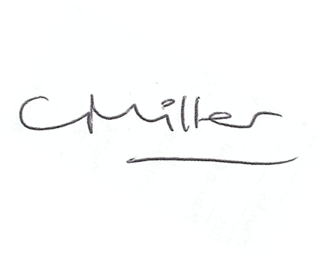Claire Miller, Clerk to Warden Parish Council

