Warden Parish Council
Chairman: Mr S Heminsley
Clerk: Claire Miller
14 Addycombe Close
Rothbury
Morpeth
NE65 7QF
Telephone: 01669 621565
Dear Councillor
You are summonsed to attend an ordinary meeting of Warden Parish Council which will take place in Newbrough Town Hall on Monday 6th January 2020 commencing at 7.00pm. A public session will be the third agenda item
AGENDA
2020/01 Apologies for Absence
2020/02 Declaration of Interests
2020/03 Opportunity for members of the public to raise any matter
2020/04 Minutes of previous meeting held on Monday 4th November 2019
2020/05 Matters arising from previous meeting held on Monday 4th November 2019 (not on agenda)
2020/06 Allotments
2020/07 Litter pick
2020/08 Roads/footpaths
2020/09 Correspondence: British Legion – grant acknowledgement
2020/10 Planning
2020/10/01 Planning Applications received:
2020/10/02 Notice of Planning application being approved:
- 19/03771/FUL: High Lodge Nether, demolition of outhouses and flat roofed extension and replacement with new extension. Internal alterations to existing stone structure and adaption of existing window and external door opening.
2010/10/03 Notice of Appeal to Secretary of State
- 18/02349/FUL: The Railway Inn, Change of use and conversion to single residential dwelling
2020/11 Reports – Town Hall; Sportsfield Association; Northumberland County Council
2020/12 Financial Matters
2020/12/01 Payments: C Miller – November, December Salary £311.61 & expenses £41.11; HMRC £40.60
2020/12/02 Request for Grant received (£1900 available in grant budget): Core Music; Community Action Northumberland; Fourstones with Warden Methodist Chapel; St Michaels, request for £950 towards graveyard maintenance; Citizens Advice Northumberland; Tynedale Hospice at Home towards hospital transport service; Newbrough Town Hall; Grants awarded f/y ending 31/3/19 as follows: Core Music £50; Community Action Northumberland £50; Tyndale Hospice £100; Newbrough Town Hall £1000; St Michaels £900 towards graveyard maintenance.
2020/12/03 Financial Planning for remainder of current year and 2020-2021
2020/12/04 To approve precept 2020-2021
2020/14 Parish Council noticeboard at garage
2020/15 The Railway Inn
2020/16 Flooding – modelling improvements across the Tyne Valley
2020/17 2020 Northumberland Day
2020/18 Northumberland County Council – Consultation on library services
2020/19 Communications – to confirm actions from this meeting
2020/20 Date and Time of Next Meeting (Monday 2nd March 2020)
MEMBERS OF THE PUBLIC ARE WELCOME TO ATTEND
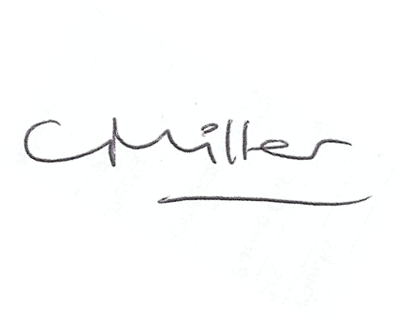Claire Miller, Clerk to Warden Parish Council

