Warden Parish Council
Chairman: Mr S Heminsley
Clerk: Claire Miller
14 Addycombe Close
Rothbury
Morpeth
NE65 7QF
Telephone: 01669 621565

Dear Councillor
You are summonsed to attend an electronic meeting of the Parish Council to be held at 7pm on Monday 7th September 2020 commencing 7pm. The public are welcome to observe.
Join Zoom Meeting
https://us02web.zoom.us/j/89015473035?pwd=Y0xpN3FYVGFjbERLdWR4WUZpR3A0UT09
Meeting ID: 890 1547 3035
Passcode: 177095

AGENDA
2020/64 Apologies for Absence
2020/65 Declaration of Members Interests
2020/66 Opportunity for members of the public to raise any matter
2020/67 Minutes of previous meeting held on Monday 6th July 2020
2020/68 Action Points and Matters arising from previous meeting held on Monday 6th July 2020 (not on agenda)
2020/69 Allotments
2020/70 Litter pick
2020/71 Roads/footpaths:
2020/71/01 Progress regarding the reduction in speeding traffic through the villages; installation of vehicle activated speed calming apparatus at C234 Fourstones;
2020/71/02 To approve Newbrough First School Safety Scheme
2020/71/03 To approve request for litter bin, layby to west of Warden level crossing
2020/71/04 To approve Local Transport Plan requests 2021-2022
2020/71/05 To consider hedgerow obstructions
2020/72 Correspondence
2020/73 Planning
2020/73/01 Planning Applications received:
- 20/01107/CCM: Prudham Quarry, extraction of sandstone
- 20/02263/FUL: Hillside, Fourstones, Internal alterations to single-storey dwelling, conversion of garage to kitchen, new garage extension with new hallway and ancillary parking
2020/73/02 Notice of Planning application being approved:
2020/73/03 Northumberland Local Plan Examination – Consultation on additional evidence (July to September 2020)
2020/74 Reports – Town Hall; Sportsfield Association; Northumberland County Council
2020/75 Financial Matters
2020/75/01 To note that following the conclusion of the 2021/21 NJC pay award, a 2.75% rise backdated from 1/4/20 would be included in Clerk salary payment November 2020
2020/75/02 Payments due: C Miller – July, August Salary £326.61; expenses £10.71 HMRC £25.60; DH Charlton, gardening - £320.00; B Gustard, gardening - £320.00
2020/75/03 Financial Planning for 2020-2021
2020/75/04 To approve repair to or replacement bench near St Aidan’s Church

2020/76 Parish Council noticeboard at garage: update on cleansing product for inside of board
2020/77 The Railway Inn: Update on planning appeal
2020/78 Flooding – modelling improvements across the Tyne Valley
2020/79 To discuss re-opening of play area and risks associated due to Covid-19
2020/80 Climate Change Group – to receive update
2020/81 Web-site Accessibility Regulations
2020/82 Communications – to confirm actions from this meeting
2020/83 Date and Time of Next Meeting (Monday 2nd November 2020)
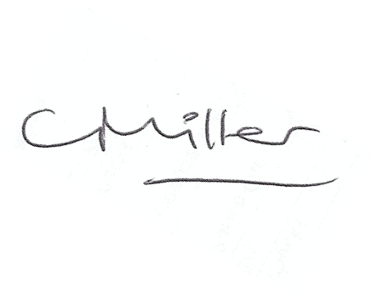Claire Miller, Clerk to Warden Parish Council

