Warden Parish Council
Chairman: Mr S Heminsley
Clerk: Claire Miller
14 Addycombe Close
Rothbury
Morpeth
NE65 7QF
Telephone: 01669 621565

Dear Councillor
You are summonsed to attend an electronic meeting of the Parish Council to be held at 7pm on Monday 4th January 2021. The public are welcome to observe.
Join Zoom Meeting
https://us02web.zoom.us/j/81043528115?pwd=QWRiYnV4NXNGSGJGYWpGR0dlZk96UT09
Meeting ID: 810 4352 8115
Passcode: 532826

AGENDA
2021/01 Apologies for Absence
2021/02 Declaration of Members Interests
2021/03 Opportunity for members of the public to raise any matter
2021/04 Minutes of previous meeting held on Monday 2nd November 2020
2021/05 Action Points and Matters arising from previous meeting held on Monday 2nd November 2020 (not on agenda)
2021/06 Allotments
2021/07 Litter pick
2021/08 Roads/footpath
2021/08/01 Progress regarding the reduction in speeding traffic through the villages
2021/08/02 Litter bin, layby to west of Warden level crossing
2021/08/03 To consider hedgerow obstructions
2021/09 Correspondence
2021/10 Planning
2021/10/01 Planning Applications received:
2021/10/02 Notice of Planning application being approved:
- 20/02931/LBC: Listed Building Consent/replacement of arched windows – Martlet, Fourstones
2021/11 Reports – Town Hall; Northumberland County Council
2021/12 Financial Matters
2021/12/01 Payments due: C Miller – November, December Salary and salary owing further from 1/4/20 further to payrise £485.62; expenses - £17.53 HMRC £65.20
2021/12/02 To consider request for grants from Tynedale Hospice at Home; Coremusic
2021/12/03 Financial Planning for 2020-2021
2021/12/04 To consider budget and precept requirements 2021-2022
2021/12/05 Meeting with PCC regarding grasscutting grant
2021/12/06 To receive acknowledgement of grant from British Legion Poppy Appeal; Sport Tynedale; St Michael’s Warden; Great North Air Ambulance

2021/13 The Railway Inn
2020/14 North East Transport plan

2021/15 Flooding – modelling improvements across the Tyne Valley

2021/16 Boatside Inn - play area and defibrillator

2021/17 Climate Change Group – to receive update

2021/18 Communications – to confirm actions from this meeting

2021/19 Date and Time of Next Meeting (Monday 4th March 2021)

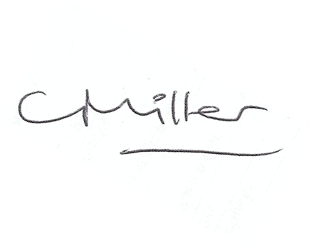Claire Miller, Clerk to Warden Parish Council

