Warden Parish Council
Chairman: Mr S Heminsley
Clerk: Claire Miller
14 Addycombe Close
Rothbury
Morpeth
NE65 7QF
Telephone: 01669 621565
Dear Councillor
You are summonsed to attend an ordinary meeting of Warden Parish Council which will take place in Newbrough Town Hall on Monday 2nd March 2020 commencing at 7.00pm. A public session will be the third agenda item
AGENDA
2020/21 Apologies for Absence
2020/22 Declaration of Interests
2020/23 Opportunity for members of the public to raise any matter
2020/24 Minutes of previous meeting held on Monday 6th January 2020
2020/25 Action Points and Matters arising from previous meeting held on Monday 6th January 2020 (not on agenda)
2020/26 Allotments
2020/27 Litter pick
2020/28 Roads/footpaths:
2020/28/01 Progress regarding the reduction in speeding traffic through the villages
2020/28/02 Request for litter bin, layby to west of Warden level crossing
2020/29 Correspondence: CPRE newsletter; County Council, Public Spaces Protection Orders, Alcohol consumption in designated public spaces
2020/30 Planning
2020/30/01 Planning Applications received:
2020/30/02 Notice of Planning application being approved:
2020/31 Reports – Town Hall; Sportsfield Association; Northumberland County Council
2020/32 Financial Matters
2020/32/01 Payments: C Miller – January, February Salary £311.61 & expenses £35.97; HMRC £40.60. S Heminsley – reimbursement for noticeboard materials - £36.00
2020/32/02 Financial Planning for 2020-2021
2020/32/03 Request for Grant Newbrough Town Hall towards work to chimney stack; electric panel heaters or main hall floor
2020/32/04 Request for Grant, St Michaels Warden for grounds maintenance
2020/32/05 To receive acknowledgement of grant from Sport Tynedale/Community Action Northumberland/Tynedale Hospice at Home; Citizens Advice Bureau; Core Music
2020/32/06 Update on costs of repair to the Millennium Beacon
2020/33 Parish Council noticeboard at garage: update on consultation and progress made
2020/34 The Railway Inn: Update on planning appeal
2020/35 Review of Internal Auditor/Internal Controls; Asset Register; Risk Assessment and Insurance Policy
2020/36 Flooding – modelling improvements across the Tyne Valley
2020/37 2020 Northumberland Day: plans for 24/5/20 event and costs
2020/38 Climate Change Group – to approve PC financial contribution and position statement
2020/39 Northumberland Association of Local Councils – Member Council Survey Anti-Social Behaviour and Petty Crime
2020/40 Communications – to confirm actions from this meeting
2020/41 Date and Time of Next Meeting (Monday 4th May 2020)
MEMBERS OF THE PUBLIC ARE WELCOME TO ATTEND
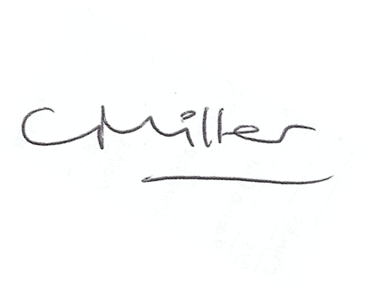Claire Miller, Clerk to Warden Parish Council

