Warden Parish Council
Chairman: Mr S Heminsley
Clerk: Claire Miller
14 Addycombe Close
Rothbury
Morpeth
NE65 7QF
Telephone: 01669 621565

Dear Councillor
You are summonsed to attend an electronic meeting of the Parish Council to be held at 7pm on Monday 6th July 2020. The public are welcome to observe. Coronavirus Legislation has removed the need for the annual meeting to be held in 2020. The appointments made at the 2019 annual meeting continue until 2021
Join Zoom Meeting
https://us02web.zoom.us/j/89406254215?pwd=QXZ3a3pUOUl4Mnl5VlJ0N2UzRW5Xdz09
Meeting ID: 894 0625 4215
Password: 593653
AGENDA
2020/42 Apologies for Absence
2020/43 Declaration of Members Interests
2020/44 Opportunity for members of the public to raise any matter
2020/45 Minutes of previous meeting held on Monday 2nd March 2020
2020/46 Action Points and Matters arising from previous meeting held on Monday 2nd March 2020 (not on agenda)
2020/47 Allotments
2020/48 Litter pick
2020/49 Roads/footpaths:
2020/50 Progress regarding the reduction in speeding traffic through the villages; installation of vehicle activated speed calming apparatus at C234 Fourstones; to receive further parishioner concerns regarding speeding traffic
2020/51 Request for litter bin, layby to west of Warden level crossing
2020/52 Correspondence
2020/53 Planning
2020/53/01 Planning Applications received:
- 20/01107/CCM: Prudham Quarry, extraction of sandstone
2020/53/02 Notice of Planning application being approved:
- 20/00517/FUL: Thistlerigg Farm, installation of biomass boiler in existing agricultural building
2020/54 Reports – Town Hall; Sportsfield Association; Northumberland County Council
2020/55 Financial Matters
2020/55/01 Payments authorised since previous meeting: C Miller – March, April Salary £304.41 & expenses £13.47; HMRC £47.80; NALC – annual subscription - £137.66; NALC – annual website fee - £75.00; Came and Company – annual insurance premium - £401.98; DH Charlton, gardening - £430; B Gustard, gardening - £430
2020/55/02 Payments due: C Miller – May, June Salary £349.21; HMRC - £3.00; DH Charlton, gardening; B Gustard, gardenng
2020/55/03 Financial Planning for 2020-2021
2020/55/04 To receive acknowledgement of grant from Warden PCC
2020/55/05 To approve quotation for costs to repair the Millennium Beacon
2020/56 Audit of Accounts year ending 31/3/20
2020/56/01 To consider and agree any actions arising from the report of the internal auditor
2020/56/02 To approve the Governance Statement
2020/56/03 To approve the draft annual accounts for 2019/2020
2020/56/04 To approve the Accounting Statement and explanation of variances
2020/56/05 To approve the Exemption Certificate

2020/57 Parish Council noticeboard at garage: update on cleansing product for inside of board
2020/58 The Railway Inn: Update on planning appeal
2020/59 Flooding – modelling improvements across the Tyne Valley
2020/60 To receive annual ROSPA inspection report; to discuss re-opening of play area and risks associated due to Covid-19
2020/61 Climate Change Group – to receive update
2020/62 Web-site Accessibility Statement
2020/63 Communications – to confirm actions from this meeting
2020/64 Date and Time of Next Meeting (Monday 7th September 2020)
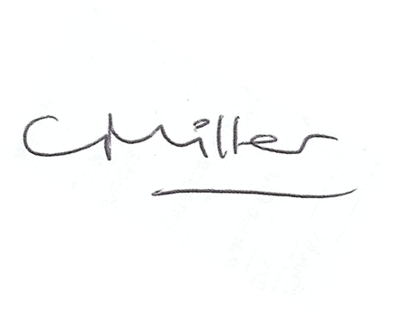Claire Miller, Clerk to Warden Parish Council

