Warden Parish Council
Chairman: Mr S Heminsley
Clerk: Claire Miller
14 Addycombe Close
Rothbury
Morpeth
NE65 7QF
Telephone: 01669 621565
Dear Councillor
You are summonsed to attend an electronic meeting of the Parish Council to be held at 7pm on Monday 2nd November 2020. The public are welcome to observe.
Join Zoom Meeting
https://us02web.zoom.us/j/84224043415?pwd=TjFDVnNMNnNjeFQ4WXN4WkJEQlB2Zz09
Meeting ID: 842 2404 3415
Passcode: 399258
AGENDA
2020/84 Apologies for Absence
2020/85 Declaration of Members Interests
2020/86 Opportunity for members of the public to raise any matter
2020/87 Minutes of previous meeting held on Monday 7th September 2020
2020/88 Action Points and Matters arising from previous meeting held on Monday 7th September 2020 (not on agenda)
2020/89 Allotments: Request to erect greenhouse on plot
2020/90 Litter pick
2020/91 Roads/footpath
2020/91/01 Progress regarding the reduction in speeding traffic through the villages; installation of vehicle activated speed calming apparatus at C234 Fourstones; Parishes of Newbrough and Warden, Diversion Order 2020
2020/91/02 Litter bin, layby to west of Warden level crossing
2020/91/03 To consider hedgerow obstructions
2020/91/04 Police Commissioners Survey
2020/92 Correspondence
2020/93 Planning
2020/93/01 Planning Applications received:
- 20/02580/FUL: Warden Estates, Retrospective application for single storey kitchen and porch extension to rear of Laverick Cottage
- 20/03030/LBC: Martlet East Fourstones – Listed building consent to install new windows which open in, entirety, opening on left side for fire escape, windows to look identical as 19/01220/LBC
- 20/02931/LBC: Martlet Fourstones – Listed building consent, replacement of arched windows
- 20/03139/FUL: Warden Barns, Low Warden – alteration and extension to existing kitchen by 2 metres outwards. Addition of porch, bootroom and en suite to rear of property located where existing store is
2020/93/02 Notice of Planning application being approved:
2020/93/03 Northumberland Local Plan Examination – Phase 2 Examination Hearings
2020/94 Reports – Town Hall; Sportsfield Association; Northumberland County Council
2020/95 Financial Matters
2020/95/01 Payments due: C Miller – September, October Salary £335.45; HMRC £55.60; Remembrance Day wreath
2020/95/02 Request for grant – Great North Air Ambulance; St Michael’s Warden; Stanegate Magazine
2020/95/03 Financial Planning for 2020-2021
2020/95/04 To consider budget and precept requirements 2021-2022
2020/96 The Railway Inn
2020/97 Flooding – modelling improvements across the Tyne Valley
2020/98 Boatside Inn - play area and defibrillator
2020/99 Climate Change Group – to receive update
2020/100 Web-site Accessibility Regulations
2020/101 Communications – to confirm actions from this meeting
2020/102 Date and Time of Next Meeting (Monday 4th January 2021)

PART TWO
That under the Public Bodies (Admission to Meetings) Act 1960, the public and representatives of the press and broadcast media be excluded from the meeting during the consideration of the following items of business as publicity would be prejudicial to the public interest because of the confidential nature of the business to be transacted.

2020/103/PRIVATE Review of Clerk’s Salary – Discussed in private due to personal information.

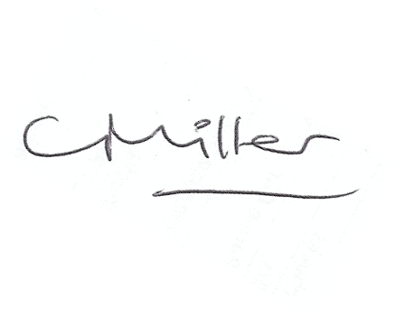Claire Miller, Clerk to Warden Parish Council

