Warden Parish Council
Chairman: Mr S Heminsley
Clerk: Claire Miller
14 Addycombe Close
Rothbury
Morpeth
NE65 7QF
Telephone: 01669 621565

Dear Councillor
You are summonsed to a meeting of the Parish Council to be held at 7pm on Monday 6th September 2021 in Newbrough Town Hall. The public are welcome to observe.
AGENDA
2021/82 Apologies for Absence
2021/83 Declaration of Members Interests
2021/84 Opportunity for members of the public to raise any matter
2021/85 Minutes of previous meeting held on Monday 5th July 2021
2021/86 Action Points and Matters arising from previous meeting held on Monday 5th July 2021 (not on agenda)
2021/87 Allotments – to consider issues relating to water supply & compost heap
2021/88 Litter pick

2021/89 Roads/footpaths/village maintenance
2021/89/01 Progress regarding the reduction in speeding traffic through the villages
2021/89/02 Litter bin, layby to west of Warden level crossing
2021/89/03 To consider hedgerow obstructions
2021/89/04 To consider replacement village signage
2021/89/05 St Aidan’s Churchyard
2021/89/06 Other maintenance issues
2021/89/07 To approve Local Transport Plan requests 2022-2023
2021/89/08 To receive Wildlife & Countryside Act, 1981 – Definitive Map Modification Order (No 1) 2021

2021/90 Planning
2021/90/01 Planning Applications received:
- 20/01107/CCM: Prudham Quarry – Extraction of sandstone

2021/90/02 Notice of Planning application approved:
2021/90/03 Haydon Parish Neighbourhood Plan consultation

2021/91 Reports – Town Hall; Northumberland County Council; Cricket Club

2021/92 Financial Matters
2021/92/01 Payments due: Procut Grounds Maintenance – grasscutting, cricket club - £60.00; C Miller – July, August Salary - £387.30; Expenses - £49.47; HMRC – £12.40 - B Gustard- gardening/village maintenance - TBC; D H Charlton – gardening/village maintenance - TBC
2021/92/02 To receive update on BACS payment method
2021/92/03 Seat repair at Homers Lane
2021/92/04 Gas testing of Millennium Wheel burners

2021/93 The Railway Inn
2021/94 Flooding – modelling improvements across the Tyne Valley

2021/95 Climate Change Group – to receive update
2021/96 To consider 70 year Queen Elizabeth celebrations June 2022
2021/97 To consider moving relocating seat at St Aidan’s due to its proximity to dog waste bin
2021/98 To consider invitation for County Council Cabinet Member to meet with Parish Council
2021/99 Date and Time of Next Meeting (Monday 1st November 2021)

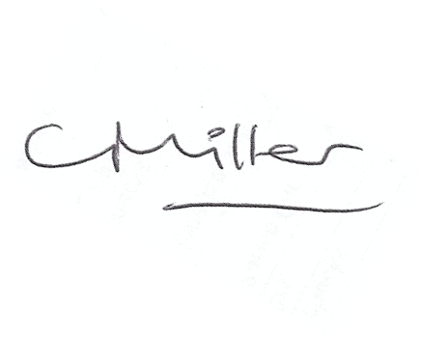Claire Miller, Clerk to Warden Parish Council

