Warden Parish Council
Chairman: Mr S Robson
Clerk: Claire Miller
14 Addycombe Close
Rothbury
Morpeth
NE65 7QF
Telephone: 01669 621565

Dear Councillor
You are summonsed to a meeting of the Parish Council to be held at 7pm on Monday 10th January 2022 in Newbrough Town Hall. The public are welcome to observe.
AGENDA
2022/01 Apologies for Absence
2022/02 Declaration of Members Interests
2022/03 Opportunity for members of the public to raise any matter
2022/04 Minutes of previous meeting held on Monday 1st November 2021
2022/05 Allotments – to consider issues relating to water supply
2022/06 Litter pick

2022/07 Roads/footpaths/village maintenance
2022/07/01 Progress regarding the reduction in speeding traffic through the villages
2022/07/02 Litter bin, layby to west of Warden level crossing
2022/07/03 Footpath clearance works/hedgerow obstructions, including Broadway to East Fourstones
2022/07/04 To receive update on proposed village signage – to approve costs for stone signage
2022/07/05 To receive update on signage east of Paper Mill requiring replacing
2022/07/06 To receive update on road sinkage at fire hydrant, top of store bank
2022/07/07 To consider recyclable seating at Crossgates
2022/07/08 To consider one-way proposal on Eastfourstones Lane
2022/07/09 To consider parishioner suggestions for rewilding areas

2022/08 Planning
2022/08/01 Planning Applications received
- 21/04541/FUL: 4 Quality Cottages – single storey porch attached to the west-facing side of the house.

2022/09 Reports
2022/09/01 Town Hall
2022/09/02 Northumberland County Council
2022/09/03 Cricket Club

2022/10 Financial Matters
2022/10/01 Payments due: C Miller – November, December Salary - £439.50; Expenses - £77.90;
2022/10/02 To receive update on BACS payment method
2022/10/03 Gas testing of Millennium Wheel burners/solar powered lighting around Beacon basket – to approve quotation for gas testing/upgrade works; to consider green bio LPG
2022/10/04 To consider grant request from Tynedale Hospice from Home
2022/10/05 To receive acknowledgement of grants from Sport Tynedale, British Legion and Friends of Newbrough School

ORGANISATION | REASON | AMOUNT REQUESTED
GRANTS AWARDED YE 31/3/21
Stanegate | Production costs | £600
St Michaels Warden | Grounds maintenance | £950
Great North Air Ambulance | General running costs | £60
Northumberland Age UK | General running costs | £60
Sport Tynedale | General running costs | £60
Core Music | General running costs | £60
Tynedale Hospice at Home | General running costs | £120
Citizens Advice Northumberland | General running costs | £60

2022/10/06 To approve budget 2022-2023
2022/10/07 To approve precept requirements of £9250 2022-2023
2022/10/08 To consider proposals for Section 106 funding available for the parish

2022/11 The Railway Inn

2022/12 Climate Change
2022/12/01 To receive update from Climate Change Group
2022/12/02 To consider Parish Council declaring a Climate Emergency

2022/13 To consider 70 year Queen Elizabeth celebrations June 2022
2022/13/01 To approve financing commemorative mugs for Newbrough School pupils

2022/14 To consider Parish Council response to emergencies within the parish
2022/15 To consider supporting Transport North East to deliver its programme of zero emission buses
2022/16 To receive items for next meeting
2022/17 Date and Time of Next Meeting (Monday 7th March 2022)

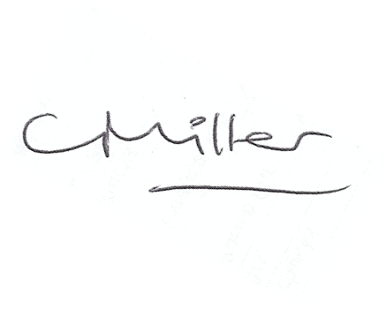Claire Miller, Clerk to Warden Parish Council

