CONFIRMATION OF THE DATES OF THE PERIOD FOR THE EXERCISE OF PUBLIC RIGHTS

Name of smaller authority: Longframlington Parish Council

County Area: Northumberland

On behalf of the smaller authority, I confirm that the dates set for the period for the exercise of public rights are as follows:

Commencing on Monday 14 June

and ending on Friday 23 July 2021

Signed:
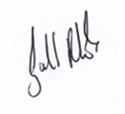

Role: Parish Clerk/RFO

