Warden Parish Council
Chairman: Mr S Robson
Clerk: Claire Miller
14 Addycombe Close
Rothbury
Morpeth
NE65 7QF
Telephone: 01669 621565

Dear Councillor
You are summonsed to a meeting of the Parish Council to be held at 7pm on Monday 7th March 2022 in Newbrough Town Hall. The public are welcome to observe.
AGENDA
2022/18 Apologies for Absence
2022/19 Declaration of Members Interests
2022/20 Meeting with Environment Agency
2022/21 Opportunity for members of the public to raise any matter
2022/22 Minutes of previous meeting held on Monday 10th January 2022
2022/23 Allotments – to consider issues relating to water supply
2022/24 Litter pick

2022/25 Roads/footpaths/village maintenance
2022/25/01 Progress regarding the reduction in speeding traffic through the villages
2022/25/02 Litter bin, layby to west of Warden level crossing
2022/25/03 Footpath clearance works/hedgerow obstructions, including Broadway to East Fourstones
2022/25/04 To receive update on proposed village signage – to approve costs for stone signage
2022/25/05 To receive update on signage east of Paper Mill requiring replacing
2022/25/06 To receive update on recycled seating at Crossgates
2022/25/07 To consider one-way proposal on Eastfourstones Lane
2022/25/08 To consider parishioner suggestions for rewilding areas
2022/25/09 To receive update on cleansing of Give Way signage at North Bank, Fourstones

2022/26 Planning
2022/26/01 Planning Applications received
2022/26/02 Frankham Quarry Planning Application

2022/27 Reports
2022/27/01 Town Hall
2022/27/02 Northumberland County Council
2022/27/03 Cricket Club

2022/28 Financial Matters
2022/28/01 Payments due: C Miller – January, February Salary - £339.70 ; Expenses - £38.10
2022/28/02 To receive update on BACS payment method
2022/28/03 To consider request for grant from Citizens Advice Northumberland (£60 granted y/e 31/3/21) and Northumberland Age UK (£60 granted y/e 31/3/21

2022/28/04 Gas testing of Millennium Wheel burners/solar powered lighting around Beacon basket – to approve quotation for gas testing/upgrade works

2022/28/05 To consider proposals for Section 106 funding available for the parish
2022/28/06 To receive acknowledgement of grant from Tynedale Hospice at Home

2022/29 The Railway Inn

2022/30 Climate Change
2022/30/01 To receive update from Climate Change Group

2022/31 To consider 70 year Queen Elizabeth celebrations June 2022

2022/32 To consider Parish Council response to emergencies within the parish; to consider responding to
County Council Storm Arwen Review

2022/33 Review of Asset Register and Risk Assessment

2022/34 Review of Internal Controls
2022/35 Review of Internal Auditor
2022/36 Review of Insurance Policy

2022/37 To receive items for next meeting
2022/38 Date and Time of Next Meeting (Monday 9th May 2022)

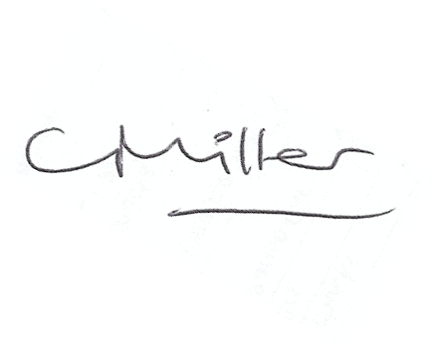Claire Miller, Clerk to Warden Parish Council

