2022 PARISH COUNCIL AGM
TREE PROJECT
During the past year parish council have approved a Tree Strategy to address disease in tree stock, climate change and biodiversity.
Work to convert the strategy to action has involved liaison and agreement with:
- Northumberland County Council Highways
- Northumberland County Council Tree Officer
- Northumberland County Council Marketing Department
- Landowners
- Tyne Rivers Trust
- Ovingham Community Orchard
- Whittle Dene CIC
- Ovingham Parish Council
- Woodland Trust
- Ovington Community Group
- Northern Forest Partnership (set up by Northumberland County Council)
- Ovingham First School
- Ovingham Middle School
Each of the above are stakeholders who have agreed to support financially, or by designating land for planting, or by pledging volunteer support, or provision of expertise / resources/ trees, or a combination of all these needs.
To date 350 trees have been planted. A map showing planting and planned planting areas is shown at the end of this report. The majority of planting is focused on public rights of way. This is important as donors of trees ask for the public to have access to the trees as they grow. Other planting to create copses and wildlife corridors is planned.
Bringing the strategy to life has involved a lot of planning and organisation. Local residents have been excellent at giving up their time and enthusiastically assisting with the following:
- Clearing land ahead of planting
- Transporting materials
- Planting trees
- Maintaining trees – mainly through cutting back overgrowth and weeding
- Checking tree health
- An expert in mapping tools has plotted where we have planted trees so that pdf copies can be placed on the parish council website
- Identifying ancient and/or notable trees in the parish to record on a national database
- Providing refreshments to volunteers and tree based activities for children
We participated in The Queen’s Green Canopy initiative and became the case study on Northumberland County Council’s website https://www.northumberland.gov.uk/Climate-Change/Free-trees.aspx
The strategy for tree planting and maintenance is a rolling programme. As Ash dieback gradually takes its toll on our tree stock, more trees will be planted to replace them. Sadly, there will be different tree diseases in the future. Woodland Trust have identified 23 diseases currently spreading in the UK, some as a result of imports for the horticulture trade, some due to climate change. So our tree planting programme is important to continue.
Plans are being made for the coming year to plant in new areas. This will comprise new hedgerows as well as more places to plant stand-alone trees. Agreement with landowners has been made to create a linear arboretum of native trees. A lot of planting needs to be done before the arboretum can be ‘launched’.
Many thanks to all who have helped over the past year.
If you would like to be involved with the Ovington Tree project, please contact Anne Hudson, Parish Councillor, at anne.hudson@live.co.uk or 07785 905624.

Ovington Tree planting - Maps showing sites of planting 2021-2022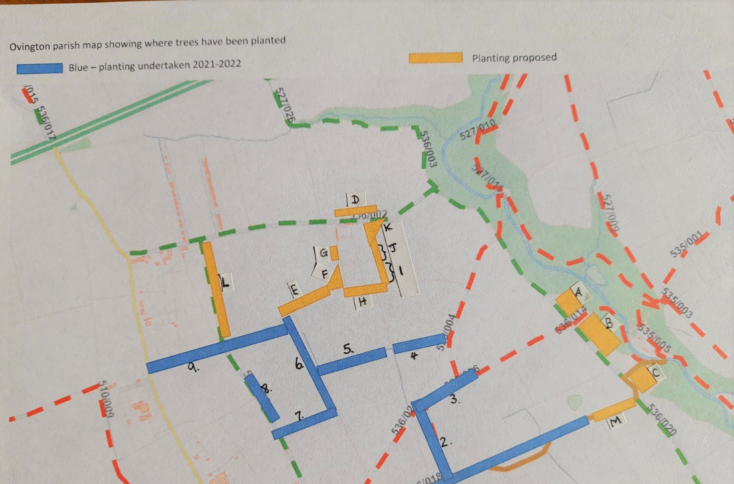
Above =North of St Andrews Lane

Below = South of St Andrews Lane
