Contacts :
Clerk –Paul Burns
07477 472021

Chair Cemetery Committee
Elisabeth Haddow
O16675 575629

Committee Members

Stephen Elliott -01665 575043
Edith Hood – 01665 575704
Celia Lewis -01665 575088

SHILBOTTLE CEMETERY

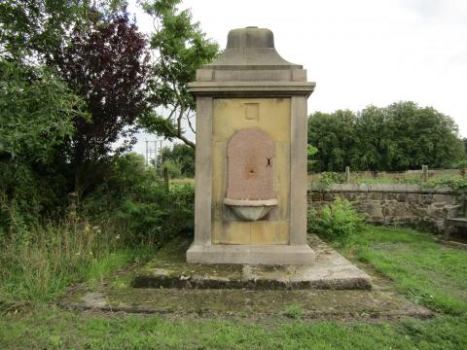

INFORMATION BOOKLET
November 2022
Information sheet for:
- Relatives of deceased persons who are to be interred
within Shilbottle Cemetery.
2. Undertakers who may be asked questions in regard to procedure.
- Stone masons who may be employed to do work in the cemetery.

- Shilbottle Cemetery comes under the jurisdiction of Shilbottle Parish Council. Management of the cemetery is delegated to a Committee of elected Councillors and the Parish Clerk. The Committee reports back to full Council on a monthly basis.

- The Committee is responsible for liaising with the Cemetery Caretaker, Funeral Directors and Grave diggers to ensure an efficient and compassionate burial for your deceased relatives. They also ensure the cemetery is kept tidy and within the bounds of the Cemetery Rules and Regulations.

- Essential funding for the maintenance and upkeep of the cemetery is raised via the Precept which comes to the Parish Council from Northumberland County Council via your Council Tax.

To ensure there is adherence to Cemetery rules and procedures we ask that relatives comply with the following:

- A plan of all proposed memorials must be submitted to the Clerk and passed by the Parish Council before any work is commenced.
- No name or other words are to be carved or otherwise written on the back of the headstone
- No advertising by any monumental mason may be visible on any part of the headstone
- No large stone containers or ornaments are to be sited on the surface of the grave.
- No lights, including solar or LED , or toys of any kind may be placed on graves or in any part of the cemetery.

The cemetery caretaker will remove items which do not comply.
All users of the cemetery should be aware that the ground underfoot is very soft, the soil is sand based and therefore care should be taken when approaching the grave side. Shilbottle Parish Council is not responsible for trips slips and falls.
The current charges are effective until March 31st. 2022
Purchase of single plot £200 Plot for interment of ashes £200 Fees for interment of ashes £75 Burial fees £200 Administration fees for headstone £75
There are no fees to scatter ashes, but this cannot take place without the prior agreement of the Parish Council.

These regulations are subject to an annual review and therefore costs may alter.

