Warden Parish Council
Chairman: Mr S Robson
Clerk: Claire Miller
14 Addycombe Close
Rothbury
Morpeth
NE65 7QF
Telephone: 01669 621565

Dear Councillor
You are summonsed to an ordinary meeting of the Parish Council to be held on Monday 7th November 2022 commencing at 7pm in Newbrough Town Hall. The public are welcome to observe.
AGENDA
2022/89 Apologies for Absence
2022/90 Declaration of Members Interests
2022/91 Opportunity for members of the public to raise any matter
2022/92 Minutes of previous meeting held on Monday 5th September 2022
2022/93 Allotments
2022/93/01 To receive update on pump for well

2022/94 Litter pick

2022/95 Roads/footpaths/village maintenance
2022/95/01 Progress regarding the reduction in speeding traffic through the villages
2022/95/02 Footpath clearance works/hedgerow obstructions
2022/95/03 To receive update on proposed village signage/planters
2022/95/04 To receive update on recycled seating at Crossgates
2022/95/05 To receive update on Dog Fouling Warning signage at Crossgates
2022/95/06 To receive update on play area repairs
2022/95/07 To consider issues with refuse burning at St Aidan’s Yard

2022/96 Planning
2022/96/01 Planning Applications received
- 22/03350/VARYCO: Hillside, Fourstones – Variation of conditions 4 & 7 on 20/002263/FUL
2022/96/02 To consider issues relating to Prudham Quarry Planning Proposals

2022/97 Reports
2022/97/01 Town Hall
2022/97/02 Northumberland County Council
2022/97/03 Sportsfield Association

2022/98 Financial Matters
2022/98/01 Payments to be authorised: Border Stone Quarries – 2 No name signs - £634.80; C Miller – September, October Salary - £406.64; Expenses - £36.67; D H Charlton/B Gustard – gardening – TBC; S Robson – British Legion wreath - £50.00; Mijan Ltd – accounts package until 31/3/23 - £30
2022/98/02 To consider grant requests from the following:
- Sport Tynedale - £60.00 granted November 2021
- Tynedale Hospice at Home - £120 granted January 2022
- Stanegate Magazine - £600 granted November 2020
- Newbrough First School – Repair to MUGA steel fencing - to consider setting up a working group of two Councillors from Warden and Newbrough Parish Council’s and representative(s) from the school, to explore how to establish the MUGA as a sustainable community / school facility, and agree the scope of works for the required repairs.
2022/98/03 To approve application for on-line banking and amendments to Parish Council Standing Orders
2022/98/04 To consider budget 2023-2024
2022/98/05 To consider precept requirements 2023-2024

2022/99 The Railway Inn

2022/100 To receive update from Climate Change Group

2022/101 To consider Crises Management for the parish

2022/102 Northumberland County Council - Notice of Consultation to extend the duration of a Public Spaces Protection Order for the control of dogs

2022/103 To receive items for next meeting

2022/104 Date and Time of Next Meeting (Monday 9th January 2023)

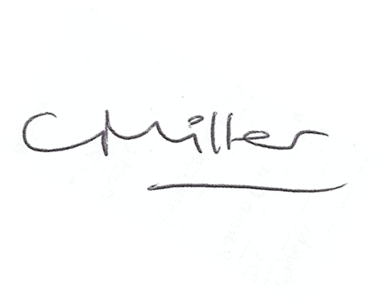Claire Miller, Clerk to Warden Parish Council

