Present | Cllr M Wood  Cllr H Maxted  Cllr B Mason | Cllr L Whitington  Cllr L Bevan | Cllr A Sharp -County  Clerk -Susan Saunders
 | Start 7.05pm
73/22 | Apologies of Absence  Cllr’s E Rimmer, E Switzer.
74/22 | Declarations of Interest  In accordance with Section 31 of the Localism Act 2011, members to declare any Pecuniary Interests in items on this agenda – None declared
75/22 | Minutes of the meetings to be approved held on  Monday 26th September 2022  PROPOSED Cllr B Mason SECONDED Cllr L Whitington AGREED
76/22 | Matters arising from previous Minutes not dealt with elsewhere in the current agenda  - The crash barriers on Glenwhelt Bank still need repairing as does the one in front of the village hall. Cllr Sharp will report to NCC.
77/22 | Chairman’s Report  Cllr Maxted reported the following:  - A poppy wreath was purchased for Remembrance Day and it was agreed to make this an annual presentation.  - It as agreed that a plaque to commemorate the Queen should be purchased and placed on the new seat on the corner grassed area.  PROPOSED Cllr H Maxted SECONDED Cllr M Wood AGREED  - Cars are getting stuck down Station Rd when they try to turn around and reverse down the ford. Cllr Sharp offered to mention signage again with NCC.  - Colin Hall from the Environment Agency has organised a meeting at Bank Foot to speak with residents in preparation of winter flooding. It is 10.30am on 29th November. Cllr E Switzer has volunteered to take on the role of flood warden in Greenhead.  - The Christmas tree is again to be donated by Mr A Newall.
78/22 | Correspondence received since the last council meeting.  - The Partnership sent an email asking for applications to be a trustee representing Greenhead and Gilsland. This role does not have to be a councillor.  - There has been information from SLCC and NALC about the new Civility & Respect protocol which included an updated Code of Conduct. The clerk will send information around and put it on the next agenda for discussion.  - A letter was received from Mr & Mrs Yeats thanking the council for replacing the plaques in the Millennium Green.
79/22 | Northumberland County Council  79/22.01 County Council report - Cllr Sharp reported the following:  - A new Chief Executive at NCC has been appointed.  - The planning for the Magna Fort has been granted.  - The trees around the play area have been pruned.  - The school is due to have an Ofsted inspection but, under the new head, appears to be improving.  - The money is in place for the signage on A69 for the low bridge outside The Sampson.  79/22.02 Other Matters  Town Parish and Community Conference Tuesday 24th January, The Mart Hexham – Cllr Maxted will attend.
80/22 | Greenhead Matters  80/22.01 Bus Shelters - it was agreed for the bus shelters on A69 to be pressure washed by Clearview Cleaning and for the clerk to request the cost to replace the missing Perspex and, instruct repair if members approve.  PROPOSED Cllr M Wood SECONDED Cllr B Mason AGREED  The ash tree in the Millennium Green will be attended to over the next few weeks.
81/22 | Land at Milburn Terrace – As Cllr Switzer was absent, it was agreed the clerk will meet up with her and discuss the report that she wrote to clarify a few items.
82/22 | Land at Tipalt – The Joicey Memorial Park  The survey report has been received and it was agreed the clerk should pass this onto Jack Bloomer for his thoughts. The survey appeared to suggest no drainage should be undertaken and that caution taken over planting trees. It is hoped that a plan can be drafted with the advice from Tyne Rivers Trust.
83/22 | Planning Applications - no plans to be considered
84/22 | Grant Requests  - British Legion – Poppy Wreath - £50  PROPOSED Cllr L Bevan SECONDED Cllr B Mason AGREED  - CAN - £50  PROPOSED Cllr L Whitington SECONDED Cllr B Mason AGREED
68/22 | Reports on Financial Matters:  85/22.01 Inc & Exp as at 23rd October 2022  85/22.02 Bank reconciliation & Accounts for payment at 21st November 2022  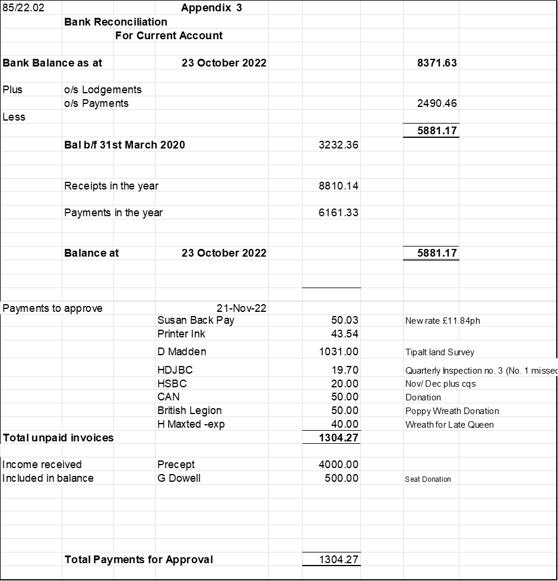  The payments of £1304.27 were approved.  PROPOSED Cllr M Wood SECONDED Cllr L Whitington AGREED  85/22.02 NJC Salaries Agreed – there is to be a pro-rated pay and then an increase of £1 per hour.  It was agreed to include this as part of the March pay.  PROPOSED Cllr L Whitington SECONDED Cllr L Bevan AGREED
86/22 | Standing Orders  Members agreed there was no need for any amendments.  PROPOSED Cllr M Wood SECONDED Cllr B Mason AGREED
87/22 | Reports:  87/22.01 H&DJBC – Sean Glenton has been appointed as the new cemetery keeper from 5th December. The notice board is still outstanding for painting and minor repairs so, it was agreed to ask Mick Yeats if he would undertake the repair.  87/22.02 Village Hall  Cllr M Wood reported that some painting work was to be undertaken in the kitchen. Toilets and outside gate.  87/22.03 Millennium Green - the replacement plaques have been fitted along with the new one for the Platinum Jubilee.  87/22.04 Play Area  Bark is required but will be considered in the spring.  87/22.05 Footpaths – no report.  87/22.06 Greenhead School – reported above.
88/22 | Dates and times of next meetings  Parish Council meeting - Monday 16th January 2023 from 7.00pm in the Village Hall.  The meeting closed at 8.45pm

