Minutes of Ford Parish Council Bi-monthly Meeting.
Tuesday 12th September 2023. 7pm, Crookham Village Hall.

- Questions from members of the public – none.
- Members present:
Cllr Baker | Chair person | Cllr Hopper
Cllr Beattie | Vice Chair | Rosanna McCorkell | Member of the public
Cllr Clark |  | Judith Stonebridge | Parish Clerk
County Cllr Hardy | County Cllr | Cllr Watson

Item |  | Action
3. | Apologies – Cllrs Brown, Denson, Musgrave & Webster. PC Daniel Perry.
4. | Declarations of interest with regard to agenda items - none
5. | Police report – PC Perry was unable to attend the meeting but provided the following update via e mail: There have been no incidents or crime of note for the Parish Council and nothing that should have a wider impact on the Ford and Etal Community. The number of crimes reported is extremely low.  Community Issues. There have been no reports of Anti-Social behaviour within the community, and again no crime trends or patterns that should currently impact.  Community Engagement. It was good to see so many local people and visitors at the Etal Show. I always enjoy attending and having the chance to speak to so many people, the show I feel is something the community should be very proud of.  A leaflet was also provided about a new initiative called Northumbria Connected this will be shared with Cllrs and added to the Parish Council website. | Clerk
6. | Approve minutes of last meeting held on 11th July 2023 – These were approved and signed by the Chair.
7. | Matters arising –  Update playground - quote to replace the swing is £207.13 (excl VAT). Cllr Baker is awaiting a response regarding the guarantee should the Estate install it. It was agreed that options for external funding would be explored by the clerk.  Update Heatherslaw Bridge – NCC have apologised for the delay in progress which was apparently due to other priorities. They have indicated that the minor repairs will be completed before winter. | Cllr Baker  Clerk
8. | Highways:  Update on issues raised:  B6345 Etal 30mph speed limit – Cllr Hardy has agreed to fund the signage. Options for the style of signage were shared and discussed. Cllr Baker to review other local signage and discuss proposed options with the Estate. It was noted that the work by NCC was to be completed by the end of the calendar year.  Damaged grit bin at Ford – this has been scheduled for the first winter repairs.  Corroded road sign -this has been scheduled for repair.  Light up safety signs Ford School – this issue has been resolved  Potholes in the Parish and flooding at Crookham were reported and have been scheduled.  There has been no response to the report about the state of the layby opposite the church, Clerk to chase.  Damage to road and footpaths following roadworks at Ford. Concerns were raised about the impact recent works have had on footpaths and roads and potential safety issues created. The Estate have raised concerns with Northumbrian Water, It was agreed that the clerk would raise concerns with NCC Highways Department. | Cllr Baker  Clerk  Clerk
9. | Planning  Consultation 23/03208/LBC Ford Village 12 & 23/03207/FUL Ford Village 12 previously circulated.  Planning Application 23/00724/FUL - relocation of Felkington Farmyard also circulated for information
10. | Cllrs Declarations of Interest - Cllrs were asked to notify the clerk of any changes to their previously submitted declarations of interest to ensure the information held by NCC was accurate and up to date. | All Cllrs
11. | Finance –  Payment approval – Crookham Village Hall Hire (£10) approved for payment.  Bank Reconcilliation & Financial update - noted.  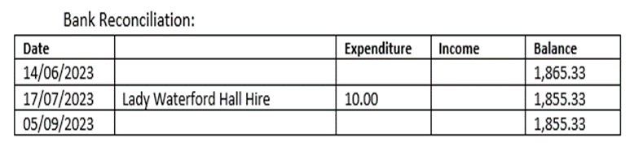  HMRC – PAYE reporting for 23/24 automatically defaulted to monthly rather than annual as a result of two salary payments having to be made in 22/23. The clerk was unaware of the changes to reporting and the Parish Council has incurred a penalty of £200 as a result of late reporting. The Clerk will explore options to appeal the penalty with Cllr Brown.
12. | Correspondence previously circulated. The following were noted: Rural services communications, NALC communications, CAN communications, information regarding free trees from NCC, support for RAF personnel and veterans and upcoming Northumberland Town & Parish Councils conference.
13. | AOB –  Concerns were raised about one of the glass recycling bins on Castle Drive now being used for general waste but not being emptied. The clerk will raise with NCC.  RMcC advised members that Guy Samson is leaving his position with Ford & Etal Estate later this week. | Clerk
14. | Next meeting – Tuesday 21st November 2023. 7pm Etal Village Hall.

