Present | Cllr H Maxted  Cllr B Mason | Cllr S Mason  Cllr M Wood | Clerk -Susan Saunders  Cllr Sharp – County Councillor
 | Start 7.00pm
45/24 | Apologies for Absence –Cllr L Whitington – prior engagement
46/24 | Declarations of Interest  In accordance with Section 31 of the Localism Act 2011, members to declare any Pecuniary Interests in items on this agenda – None declared
47/24 | Public Questions No questions
48/24 | Minutes of the meetings to be approved held on  Monday 22nd May 2024  PROPOSED Cllr M Wood SECONDED Cllr B Mason AGREED
49/24 | Matters arising from previous Minutes not dealt with elsewhere in the current agenda  The portrait of the King is now hanging in the hall.
50/24 | Correspondence received since the last council meeting  Escape Charity is making an online presentation at the Haltwhistle Town Council meeting on 2nd September which Greenhead members can attend.
51/24 | Northumberland County Council  51/24.01 NCC Yellow lines consultation – Cllr Sharp will liaise to clarify this is now going ahead.  51/24.02 Local Transport Plan –  The following were suggested and approved:  - Glenwhelt Bank – double white lines all the way up the bank with no overtaking section.  - Signage along the bank is damaged and needs repairing  - Pedestrians and cyclists still going up the road instead of using the cycle path. The council would like NCC to look into the safety concerns and make suggestions on how to address and remedy the concerns.  PROPOSED Cllr M Wood SECONDED Cllr H Maxted AGREED
52/24 | Greenhead Matters  52/24.01 Finger Point Sign – The sign should be ready in a couple of weeks.  52/24.02 Rospa Report – there are a few issues that need addressing. The clerk is to organise.  52/24.03 Greenhead Harvest Fair - the church, school and village hall committee are organising a harvest fair in September. Members offered a donation and Cllr Maxted is going to find out if there is a need. The clerk was given delegated authority to pay this if an amount is agreed in email by all members.  PROPOSED Cllr M Wood SECONDED Cllr S Mason AGREED
53/24 | Land at Milburn Terrace  The solicitors are to be asked for a price and the letter sent out.
54/24 | Planning Applications - No plans
55/24 | Reports on Financial Matters:  55/24.01 Bank Reconciliation & Accounts for payment at 15th July 2024  55/24.02 Income & Expenditure at 1st July 2024  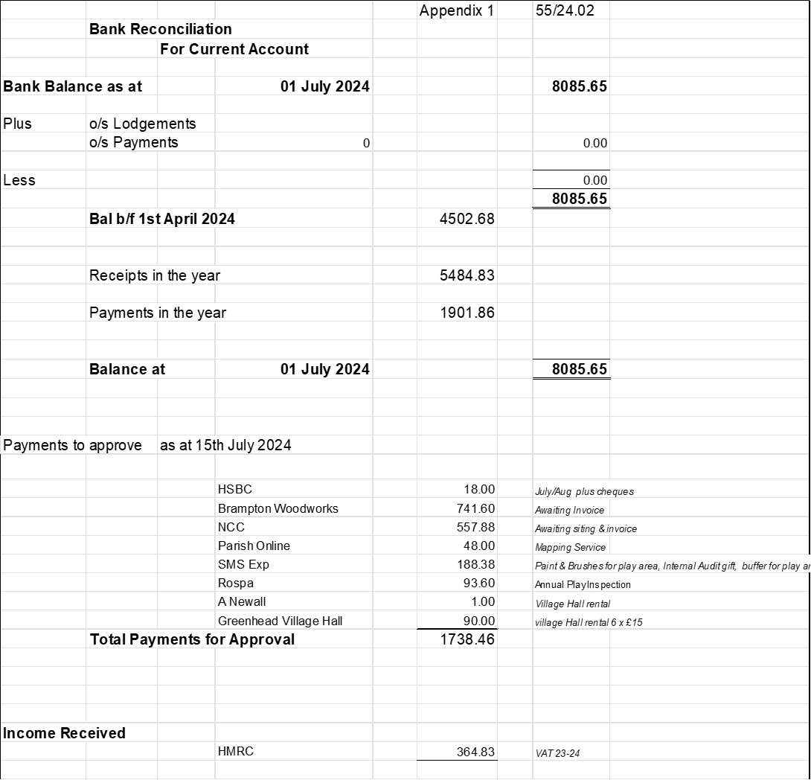  The accounts for £1738.46 were approved for payment.  PROPOSED Cllr B Mason SECONDED Cllr M Wood AGREED
56/24 | Haltwhistle & District Joint Burial Committee  Melkridge Withdrawal Report – To approve offer made to Melkridge by Haltwhistle Town Council as host authority and the Burial Committee.  Members approved the offer.  PROPOSED Cllr B Mason SECONDED Cllr M Wood AGREED  Cllr Maxted reported that Network Rail have agreed they will deal with the fallen tree and wall repair though they claim it is not their responsibility.  There are low hanging branches from the yew trees that need cutting back for when the grass is mowed.  There will be some tidying up of the footpath.
57/24 | Dates and times of next meetings  Council Meeting, Monday 16th September 2024 from 7.00pm in the Village Hall.  The meeting closed at 8.12pm.

