Present | Cllr H Maxted  Cllr B Mason  Cllr E Switzer | Cllr M Wood  Cllr S Mason | Cllr A Sharp -County  Clerk -Susan Saunders
 | Start 7.00pm
88/23 | Apologies of Absence – Cllr Whitington
89/23 | Declarations of Interest  In accordance with Section 31 of the Localism Act 2011, members to declare any Pecuniary Interests in items on this agenda – None declared
90/23 | Minutes of the meetings to be approved held on  Monday 18th September 2023  PROPOSED Cllr E Switzer SECONDED Cllr M Wood AGREED
91/23 | Matters arising from previous Minutes not dealt with elsewhere in the current agenda  No Matters
92/23 | Correspondence received since the last council meeting.  The correspondence was noted.
93/23 | Northumberland County Council  93/23.01 Finger Post - permission has been given to place it on the green in front of the war Memorial as long as there is no obstruction for vehicles exiting the street. The clerk will obtain a quote now that the design has been drawn up.  93/23.02 Meeting with Highways - Andy Olive from NCC will meet to discuss the yellow parking line. Cllr Sharp to organise the meeting.  93/23.03 Signage along Longbyre – NCC have agreed to the signage.  93/23.04 Footpath from Milburn Terrace – the path has been cleared.  93/23.05 Tarmac at Charger Point – tarmac has been placed.  93/23.06 Gate at Greenhead Bank – completed.  Members made the following requests to Cllr sharp:  - Could the digger/sweeper go up the bank past the Gilsland turning to get all the weeds out and stop the water flowing downhill.  - The drain on the corner outside the village hall is still blocked and overflowing. It needs emptying.
94/23 | Greenhead Matters  94/23.01 War Memorial - the repair work has been satisfactorily completed along with the cleaning of the stone. Members would like to thank Gary Simpson as he voluntarily undertook this work with no payment. Members agreed to purchase a £50 voucher for The Milecastle Inn in appreciation of his offer.  PROPOSED Cllr H Maxted SECONDED Cllr S Mason AGREED  94/23.02 Play Park Inspections –It was agreed that members would undertake the running inspections of the play area rather than the Burial Committee with the annual Rospa Inspection as the main one.  PROPOSED Cllr B Mason SECONDED Cllr E Switzer AGREED  94/23.02 Land at Milburn Terrace – No matters to report.
95/23 | Standing Orders & Financial Regulations  No amendments were required but members asked that the Code of Conduct could be reviewed at the next meeting. The clerk will email the Good Councillors Guide round members.  PROPOSED Cllr B Mason SECONDED Cllr L Whitington AGREED
83/23 | Planning Applications  To Determine  23NP0107 – Burnhead, change of use from residential to children’s home. – Members have no objection to the application as long as it remains as it is. Any changes in the future would need to be reconsidered.  PROPOSED Cllr S Mason SECONDED Cllr M Wood AGREED  23NP0089 – Roman Army Museum, - extension to existing facility – No Objection Submitted.  PROPOSED Cllr H Maxted SECONDED Cllr E Switzer AGREED
97/23 | Haltwhistle & District Burial Committee  97/23.01 Budget Levy Request – the committee have agreed to a standstill for 2024-2025. There may be a slight difference once the Band D figures are calculated.  97/23.01 Melkridge Updates – The report is about to go to Cabinet for a decision as to whether Melkridge can leave the committee.
98/23 | Grant Requests  98/23.01 Grant & Donation Policy – the policy was reviewed and approved.  PROPOSED Cllr S Mason SECONDED Cllr B Mason AGREED  98/23.02 Greenhead Village Hall  98/23.03 Greenhead Youth Club  The grant requests will be considered in January once the applicants complete the required paperwork.
99/23 | Reports on Financial Matters:  99/23.01 Bank Balances: Reconciliation, Inc & Exp as at 31st October 2023  99/23.02 Accounts for payment at 20th November 2023  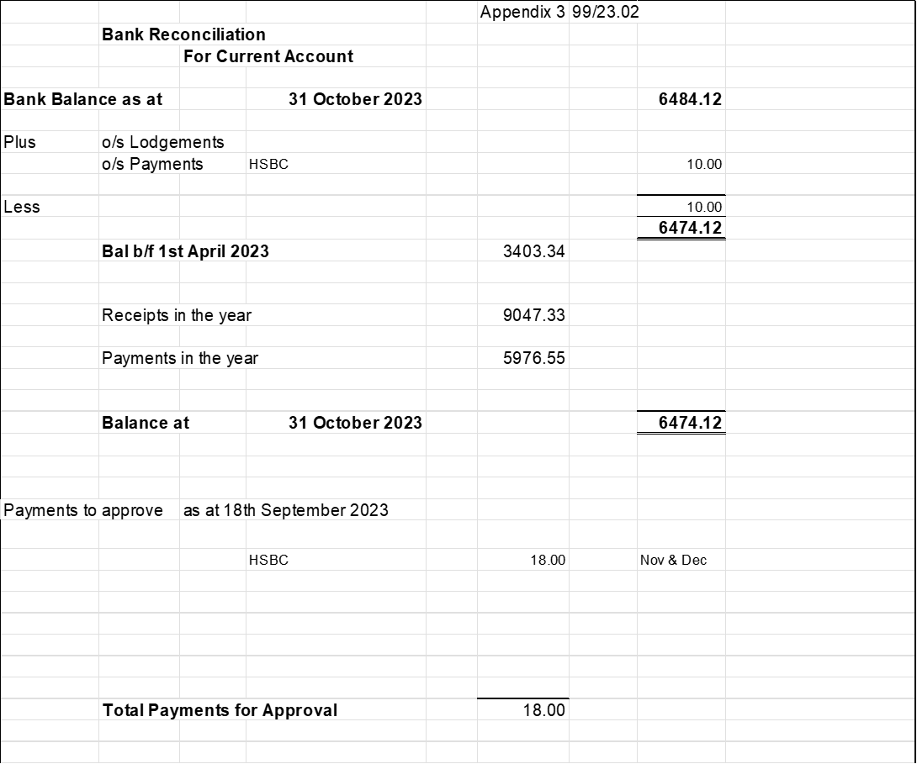  The payments of £18.00 were approved.  PROPOSED Cllr H Maxted SECONDED Cllr M Wood AGREED  99/23.03 Budget and Precept for 2024-2025 – Consideration was given to the forecast and budget for next year and it was agreed that a 5% increase would be requested. The amount of the precept will be £9240.00.  PROPOSED Cllr H Maxted SECONDED Cllr M Wood AGREED
100/23 | Any Other Matters  Cllr Wood attended the Town & Parish meeting and reported the new ‘Fix My Street’ initiative.  NCC discussed the possibility of introducing glass recycling with the bin collections. They are also looking to reduce car parking fees in some areas to nil.  Cllr Wood has been elected as the Northumberland NALC vice-president.  Cllr Sharp reported that the governors of the schools(Henshaw and Greenhead) have voted to become an academy.
101/23 | Dates and times of next meetings  Council Meeting, Monday 22nd January 2024 from 7.00pm in the Village Hall.  The meeting closed at 8.10pm

