Present | Cllr M Ridley  Cllr A Whitehead  Cllr A Dale  Cllr D Keen | Cllr A Sharp  Cllr E Walton  Cllr H Maxted | Clerk – Miss K L Heaney  Cemetery Keeper – Mr Sean Glenton  Gemma Heppell – HTC Staffing Committee
19.00 | Cllr M Ridley  Cllr A Whitehead  Cllr A Dale  Cllr D Keen | Cllr A Sharp  Cllr E Walton  Cllr H Maxted
01/25 | Meeting Started at 19:05pm, Apologies for absence – Cllr D R Mackie absent.
02/25 | Declarations of Interest  The chair reminded members of the Council of their duty to declare an interest in each agenda item.
03/25 | Matters arising from the minutes not covered elsewhere in the agenda – None
04/25 | Minutes  Minutes from 29th October 2024 and 3rd December 2024 were signed and approved.
05/25 | Clerks Report  05/25.01 Fee outstanding from the coop was paid on the 21st of January. Members requested the update from Greenhead wall to be added into draft minutes (Tree has been taken down from the wall at Greenhead Cemetery – awaiting updates regarding the wall being mended).  No further comments on the clerk’s report.
06/25 | Cemetery Matters  06/25.01 Exclusive Rights & Transfers – No exclusive rights to sign.  06/25.02 Cemetery Report – cemetery report was circulated prior to meeting – Members had no comments to make regarding cemetery report.  Greenhead Cemetery updates – Amendments to grass box to be actioned to reduce frequency oof emptying, cemetery keeper is going to start once weather improves. Members also discussed using the digger and road planings on Greenhead Cemetery path, to save money on improving the path there. Members agreed for this work to take place as long as grave levelling takes a priority alongside any other essential tasks.  06/25.03 Cemetery grounds update – cemetery wall rectified by Dominic Beverley contractor (fee included the refix of loose slates on Hearse House and repairs to the cemetery wall £150)
07/25 | Allotments  07/25.01 Allotment updates – Waiting list update circulated around members prior to the meeting. Members discussed outstanding allotment rents and instructed Clerk to send out final reminder letters (draft circulated). Clerk and cemetery keeper reported that work on the trees at Wydon Allotment is now complete.  07/25.02  The Burial Committee considered a request regarding a vacant allotment plot. Given the current waiting list, members agreed that the plot should be offered to the next person on the list. The Clerk will inform the applicant accordingly. PROPOSED Cllr A Whitehead SECONDED Cllr M Ridley AGREED
08/25 | Land registration of Haltwhistle and Greenhead Cemetery  No updates yet on Haltwhistle & Greenhead Cemetery.
09/25 | Reports on Financial Matters  09/25.01 Balances, Income and Expenditure as of 15th January 2025 – Agreed  PROPOSED Cllr M Ridley SECONDED Cllr A Dale AGREED  09/25.02 Payments for approval as of the 21st January 2025 -  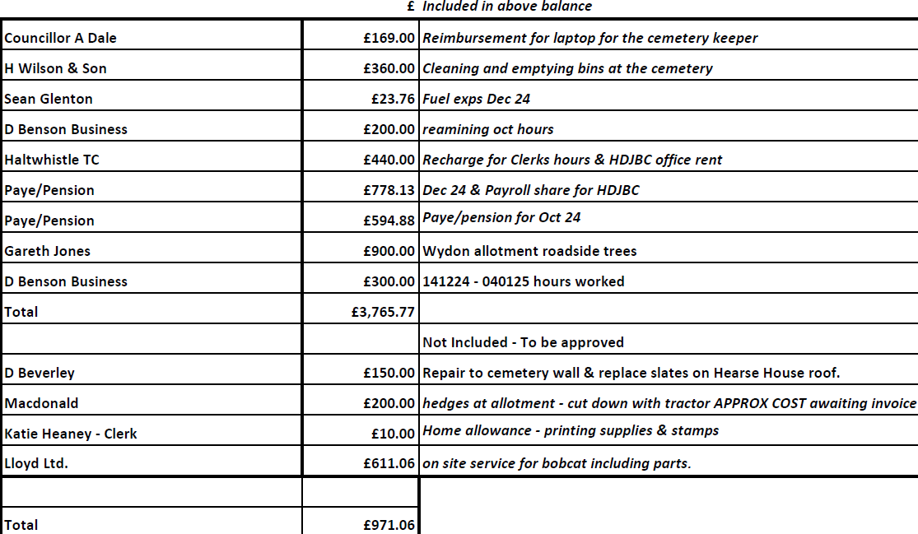  The total amount of £971.06.00 was approved.  Comments received – requested the income/expenditure to be looked at before the next meeting, ensure contracting grounds and maintenance have all the correct figures in, and ensure breakdown is up to date.  PROPOSED Cllr M Ridley SECONDED Cllr A Dale AGREED
10/25 | Melkridge Parish Council Updates & Constitution  Members agreed and signed final copy of the constitution. Members instructed clerk to email around to the other parishes, along with budget levy requests.  PROPOSED Cllr A Sharp SECONDED Cllr M Ridley AGREED
11/25 | Confidential Matters: Resolution to Exclude Press and Public  To consider a resolution to exclude the public and accredited representatives of newspapers from the following item relevant to a subject which affects the Council’s area.  Resolution  “That in view of the confidential nature of the business about to be transacted it is advisable in the public interest that the public be temporarily excluded, and they are instructed to withdraw.”  This resolution is moved under the Public Bodies (Admission to Meetings) Act 1960 (as extended by s.100 of the Local Government Act 1972), the public and accredited representatives of newspapers be excluded from the meeting for the following items of business on the grounds that it involves the likely disclosure of exempt information as defined in Part 1 of Schedule 12A of the Local Government Act 1972 by virtue of the paragraph specified against the item.  A confidential minute was taken.
12/25 | Date & Time of Next Meeting  Wednesday 5th March 2025 – Old Ticket Office Haltwhistle Train Station)  Clerk will confirm with members once next meeting is booked.  12/25.01 Meeting dates 2025 – members agreed to the dates drafted up, review December meeting date.  Meeting closed @ 20:25pm  Members requested clerk find out information regarding how soon the committee the hold a meeting after elections. Clerk to contact SLCC and NALC.

