Present | Cllr M Ridley  Cllr A Whitehead  Cllr A Dale  Cllr D Keen | Cllr A Sharp  Cllr E Walton | Clerk – Miss K L Heaney  Haltwhistle Clerk – Emma Ackroyd  Cemetery Keeper – Mr Sean Glenton
19.00 | Cllr M Ridley  Cllr A Whitehead  Cllr A Dale  Cllr D Keen | Cllr A Sharp  Cllr E Walton
93/24 | Meeting Started at 19:05pm, Apologies for absence –  Cllr H Maxted (Apologies received) & Cllr D R-Mackie. The chair opened the meeting by welcoming the new representative for Thirlwall Parish Council, Mr David Keen.
94/24 | Declarations of Interest  The chair reminded members of the Council of their duty to declare an interest in each agenda item.
95/24 | Matters Arising – None
96/24 | Minutes  Minutes from Wednesday 19th September 2024 were, approved and signed.  PROPOSED Cllr A Sharp SECONDED Cllr A Whitehead AGREED
97/24 | Clerks Report  97/24.01 Members received the clerks report and agreed to approve the invoice incoming from D Beverley regarding the Hearse House roof, to get the invoice paid as soon as received, circulate if a lot higher than quotation. Members also asked Clerk to contact Network rail regarding newer update on the wall at Greenhead Cemetery.  PROPOSED Cllr A Sharp SECONDED Cllr M Ridley AGREED
98/24 | Cemetery Matters  98/24.01 Exclusive Rights & Transfers  98/24.02 Cemetery Report – cemetery report was circulated prior to meeting – members had query regarding hedge cutting season and nesting season, otherwise nothing to report.  98/24.03 Hearse House Update – Updates received, works complete so we are just awaiting the invoice.
99/24 | Allotments  99/24.01 Report from walkaround (071024) – circulated to members prior to the meeting. Members received quotes for additional taps at Wydon Allotments and also the quote for trimming/pruning the trees on the roadside, near allotment parking. Members AGREED to still defer the taps installation of the taps until spring next year, however we can look for quotes now but state on the quote request that this work will be mainly for spring next year. Members AGREED to focus on seeking quotes regarding the trees as members agree if left, they could cause more a safety issue.  PROPOSED Cllr M Ridley SECONDED Cllr A Dale AGREED  99/24.02 Waiting List Updates – circulated to members prior to the meeting.
100/24 | Land registration of Haltwhistle and Greenhead Cemetery  No updates received at current time/date.
101/24 | Reports on Financial Matters  101/24.01 Balances, Income and Expenditure as of 24th October 2024 – Agreed  PROPOSED Cllr A Dale SECONDED Cllr M Ridley AGREED  101.24.02 Payments for approval as of the 24th October 2024 -  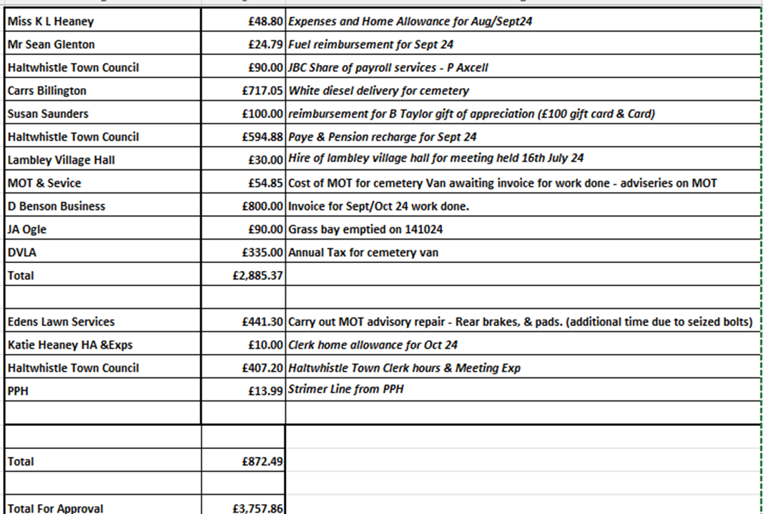  The payment totals of £3,757.86 were agreed and approved. The Committee also discussed the the new office becoming available with Haltwhistle Town Council. Members agreed that based on HDJBC Clerk’s hours it was AGREED Haltwhistle & District Joint Burial Committee would pay 20% of office costs/rent. Members happy for Clerks to organise payment in full.  PROPOSED Cllr M Ridley SECONDED Cllr A Sharp AGREED  101/24.03 Budget Levy for 2025 to be agreed – Members discussed the budget levy and agreed to increase the Levy for 2025 by 5%. Clerk will send out relevant information to Parishes once we have received the up-to-date Band D figures. Members would also like a letter of update in relation to Melkridge Parish Council sent out with Budget Levy information.  PROPOSED Cllr A Whitehead SECONDED Cllr A Dale AGREED  101/24.04 Barclays Mandate – to be updated. Members agreed add New Haltwhistle Town Clerk onto the mandate, along with an additional councillor, as a backup. Councillors nominated Cllr H Maxted as the additional councillor.  PROPOSED Cllr M Ridley SECONDED Cllr A Dale AGREED
102/24 | Melkridge Parish Council Updates & Constitution  No updates received regarding Melkridge. Members agreed to amend the constitution and send to NALC for review before circulating around members and parish councils.  PROPOSED Cllr E Walton SECONDED Cllr A Whitehead AGREED
103/24 | Confidential Matters: Resolution to Exclude Press and Public  To consider a resolution to exclude the public and accredited representatives of newspapers from the following item relevant to a subject which affects the Council’s area.  Resolution  “That in view of the confidential nature of the business about to be transacted it is advisable in the public interest that the public be temporarily excluded, and they are instructed to withdraw.”  This resolution is moved under the Public Bodies (Admission to Meetings) Act 1960 (as extended by s.100 of the Local Government Act 1972), the public and accredited representatives of newspapers be excluded from the meeting for the following items of business on the grounds that it involves the likely disclosure of exempt information as defined in Part 1 of Schedule 12A of the Local Government Act 1972 by virtue of the paragraph specified against the item.  103/24.01 Staffing Updates & Clerk Contract  103/24.02 Any other matters – Grounds Contract Hours Review  PROPOSED SECONDED AGREED
104/24 | Date & Time of Next Meeting  Tuesday 3rd December 2024 at 7pm – Venue to be confirmed (Old Ticket Office Haltwhistle Train Station)  Meeting closed @ 20:30pm

