Present | Cllr H Maxted  Cllr B Mason | Cllr S Mason  Cllr M Wood  Cllr L Whitington | Clerk -Susan Saunders  Cllr Sharp – County Councillor
 | Start 7.00pm
01/25 | Apologies for Absence
02/25 | Declarations of Interest
03/25 | Public Questions No questions
04/25 | Minutes of the meetings to be approved held on  Monday 18th November 2024 -minutes were accepted as a true record.  PROPOSED Cllr L Whitington SECONDED Cllr S Mason AGREED
05/25 | Matters arising from previous Minutes not dealt with elsewhere in the current agenda  Cllr Maxted has been cleaning the playground equipment but is struggling to get the green off the cradle swing. He will continue to try. The clerk will check on the lease end date.
06/25 | Correspondence received since the last council meeting  The correspondence was noted.
07/25 | Northumberland County Council (NCC)  07/25.01 County Councillor A Sharp reported the following:-  - Two signs are to be placed on the A69 to warn of walkers using the Pennine Journey crossing the road.  - The yellow lines initiative is awaiting the team to begin.  - Signs are missing on Glen Whelt Bank – Cllr Sharp will liaise with NCC  The bridge on the footpath heading to Thirlwall Castle is showing signs of damage with holes appearing. It was unclear whether this is Sustrans or NCC. Cllr Mason will take photos for the clerk to clarify.  07/25.02 Bus Improvement grant – No information has been received. Cllr Sharp will contact Neil Easton.  07/25.03 Wildlife and Countryside Act 1981 Section 53 – to receive the definitive map modification order RB Nos 27 and No 1.  07/25.04 Station Road – to discuss unauthorised vehicle access. A request from a resident has been received for members to discuss the access along this private road. It has been an issue for a number of years. Cllr Sharp offered to speak to the resident and explain the situation and ask if Neil Snowden from NCC will visit again to try and come up with a solution.
08/25 | Greenhead Matters  08/25.01 Millennium Green to approve request to manage the village green. Members approved the request.  PROPOSED Cllr M Wood SECONDED Cllr H Maxted AGREED  08/25.02 Notice Boards – to approve usage policy. The policy was accepted and approved. It is to be displayed on Facebook and the website.  PROPOSED Cllr L Whitington SECONDED Cllr S Mason AGREED
09/25 | Grant Donations  09/25.01 Tynedale Hospice - £100  PROPOSED Cllr B Mason SECONDED Cllr H Maxted AGREED  09/25.02 Sport Tynedale – members felt that there was no benefit to residents from this charity at this point in time so agreed no donation to be made.  09/25.03 Great North Air Ambulance - £100. Members agreed that this should be a standing donation with the amount to be approved each year.  PROPOSED Cllr B Mason SECONDED Cllr M Wood AGREED  09/25.04 Citizens Advice - £50  PROPOSED Cllr B Mason SECONDED Cllr H Maxted AGREED  09/25.05 Wagg & Company North East Friendship Groups – it was felt that there are other options for dog walkers in the area and that this charity was too remote to be of help in Greenhead. It was therefore agreed that no donation will be given.  09/25.06 Any other requests. It was agreed to donate to Age UK Northumberland, the amount of £50.  PROPOSED Cllr M Wood SECONDED Cllr L Whitington AGREED
10/25 | Planning Applications  No plans received
11/25 | Reports on Financial Matters:  11/25.01 Bank Reconciliation & Accounts for payment at 20th January 2025  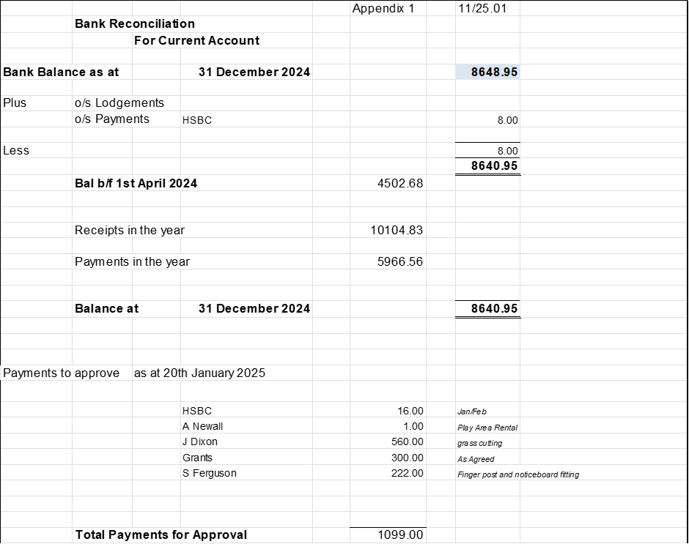  The accounts for £1099 were approved for payment with the addition of £222 for S Ferguson and £300 for grants approved on the night.  ROPOSED Cllr M Wood SECONDED Cllr L Whitington AGREED  11/25.02 Income & Expenditure at 31st December 2024 - noted  11/25.03 Budget for 2025-2026 and Precept Amount to approve.  The budget was approved with the addition of £1000 onto the maintenance column as the outside of the village hall will be painted this year and the council are responsible for the cost. It was proposed to increase the precept by 3% to £9517. This will have the following increase in council tax effect:  Band A House - £1.36  Band D House - £2.04  Band H House - £4.08  The precept was approved.  PROPOSED Cllr B Mason SECONDED Cllr H Maxted AGREED  11/25.03 Asset Register to receive - noted.
12/25 | Risk Assessments – The risk assessments now include a section to cover online banking. The clerk can set payments up and one of 2 members are required to authorise the payments.  Members approved the amendments.  ROPOSED Cllr B Mason SECONDED Cllr L Whitington AGREED
13/25 | Haltwhistle & District Joint Burial Committee  13/25.01 Melkridge Withdrawal – Amended constitution to approve - this has not been received and so will be deferred until the March meeting.  Cllr Maxted reported that the tree in the cemetery that was causing the wall to fall down, has now been removed by Network Rail.
14/25 | Any Other Matters  The chair reported that Cllr Wood is to stand down as the NALC representative for the area and the flood warden. Members were unanimous in their thanks for all the work he has undertaken in these roles over the years.  Cllr Maxted, another flood warden, will endeavour to encourage another volunteer.
15/25 | Dates and times of next meetings  Council Meeting, Monday 17th March 2025 from 7.00pm in the village hall.  The meeting closed at 8.00pm.

