Minutes of the PARISH COUNCIL MEETING
7.00 p.m. Thursday 25th November 2021
Parish Rooms, Rothbury

Present: Hilary Dunn (HD -Chair), Peter Henry (PH), Fran Tait (FT),
In attendance: Clerk: Garth Rhodes.

- Apologies for absence: Alan Tait (AT)
- Minutes of the meeting held on the Thursday 30th September 2021 were reviewed, unanimously approved as a true record and signed as such (proposed FT, seconded PH).
- Matters arising from the minutes
- Proposed Woodland Sites on the Moor at Whitton Farm – Response from landowner. The following response to the PC’s enquiry regarding the management of the woodland had been received:
- The woodland design, planting, and ongoing management is under the aegis of the Forestry Commission and is strictly controlled.
- After 9 months of consultation, a consultant approved by the Forestry commission is about to prepare a woodland design following the format approved by the FC.
- The woodland sites will be fenced with sheep netting.
- The saplings will be planted in biodegradable tubes
- The woodland sites will be managed for weed control, round the saplings and in open spaces for 10 years.
- More saplings will be planted if necessary.
The Landowner will be in Whitton from Sun 28 Nov – Sat 4th Dec and happy to provide further information.
Members were satisfied with the response.
New Matters
- Highways and Footways Report:
Highways Inspection:
- Speeding along Carterside Road near the pumphouse was a serious issue. This to be reported to NCC Highways for them to make recommendations as to what restrictions can be put in place
- The badly damaged road surface on the Lordenshaw road has been resurfaced to a good standard at the southern end of the road. The rest of that road still suffers from numerous potholes.
- A pothole on Carterside Bank near the left-hand side going downhill and just above the new waste treatment installation remains. Highways have referred this to the Water Authority as it is a repair to one of the holes they dug to create the Water treatment plant which is collapsing again.
Footpaths:
- The highways department is now responsible for a number of farm track/footpaths in the parish including the U4061 from Tosson to the Ladybridge. Although their resources are focussed on the road network, Graham Bucknall has acknowledged that the southern end of the Ladybridge has a large (18 inches) drop down to the pathway. He has agreed to try to get this improved with a concrete ramp in this financial year.
Verges:
- We have used up all of the planings provided by the Highways Dept. by filling potholes in passing places. At a meeting with Wayne Gair, it was suggested that some of the graded materials they have recycled at the Powburn depot would be suitable for this work and Wayne agreed to provide a lorry load to be stored at Ryehill Farm.
- The sign at the Lordenshaw road at the east end of Tosson have yet to be replaced with lettering on both sides.
Drains:
- All of the gullies and pipe entrances of note have been checked recently and are free from debris and obstructions.
- Finance
- Receipts since the last meeting. Approved
06/09/2021 | Business Acc. 70103195 | Interest 07/06/2021-06/09/2021 | 0.05

- Clerk’s salary, expenses, PAYE & NI and Other Payments since the last meeting. Approved
Rothbury PCC CG | Parish Room booking | 100524 | 12.00
Rothbury PCC CG | Parish Room booking | 100525 | 12.00

- Requests for donations. None
- Bank Reconciliation to Thursday 25th November 2021. None
Balance per online bank statements at 21/11/2021 |  |  |  | £
 | Community account |  |  | 2536.92
 | Business Saver |  |  | 2007.17
 |  |  |  | 4544.09
Less unpresented cheques | 25/11/2021 | Rothbury PCC | 12.00
 |  |  |  | 12.00
Uncredited Deposits |  |  | 0.00
 |  |  |  | 0.00
Balance |  |  |  | 4532.09
Balance per cash book |  |  |  | 4532.09

- On-line Banking & Cheque Signatories. After some considerable effort, on-line banking for the PC was now set up. Before this could be used the online banking procedures within the Council’s Standing Orders required approval (see Item 11).
- Correspondence: To consider any key issues of correspondence. All items of importance had been included in the agenda. Other items were listed in the Correspondence List which had been previously circulated.
- Planning: To consider any planning applications and planning matters including:
- NCC Planning Applications
Reference | Address | Status | PC Comments
21/03106/FUL | Mace Convenience Store Townfoot Rothbury: New Co-op | Registered | The WTPC object to this development based on inadequate parking arrangements. The construction of the Co-op at this location will only add to the already overburdened parking and traffic management in the immediate vicinity of the proposed development which will not be welcomed by residents nor visitors to Rothbury.
21/03335/FUL  21/03336/LBC | Whitton Grange C181 Whitton Village Whitton | Registered | No objection
21/04383/FUL | Rams Wood- The Pele Tower Whitton: Single detached dwelling and restoration of historic woodland garden | Registered | No Comment - was agreed as the PC had previously agreed not to object to a similar previous application: 20/03145/FELTPO Rams Wood - The Pele Tower Whitton. It was noted that Cllr Bridget had contacted parish residents on this matter which he had never done for any previous applications.

- NNPA Planning Applications
Reference | Address | Status | PC Comments
21NP0043 | Croft House, Great Tosson: Proposed extension above existing garage | Granted  Conditionally | No Objection

- Police Report. Police Update Whitton and Tosson 29/11/21. The below information reflects Whitton and Tosson area from 1st October 2021:
Crimes reported 0
Anti- Social Behaviour 0
Other Business
We hope everyone is staying safe and well. Officers are assisting rural communities following the impact of Storm Arwen and encourage residents to look out for one another.
FARMWATCH – Please spread the word to any farmers/workers that we are here to support them and provide crime prevention advice.
Rural Crime - On Thursday night our Rural Crime Team worked with our Neighbourhood Policing Team, Special Constable's and our Rural Crime Volunteers in Operation Checkpoint, to tackle travelling criminals across the region. Briefings were held and Hexham and Alnwick Police Station, with volunteers and resources being deployed around our rural communities. In total 24 vehicles were checked, and all were in order. Officers from Northumbria Police also assisted Durham Constabulary in stopping four males who were suspected of poaching near Derwent Reservoir - males were advised accordingly and further enquiries are being conducted.
Please, if you see any suspicious vehicles or persons in the area REPORT THIS on 101 or online NORTHUMBRIA.POLICE.UK. My email address is 9395@northumbria.pnn.police.uk – if something is not urgent and you would like some advice please get in touch. Thank you – PCSO 9395 Katie Gerrard (Alnwick and Rural)
- Rothbury JBC Report. The JBC had not met since the last PC meeting so nothing further to report.
- Coquetdale Cluster Report. The leader of NCC was supposed to attend the meeting but did not and as this constituted the main part of the agenda little was achieved although a detailed police report was provided by the local community police officer. The next meeting to take place on 29th March 2022.
- To review of the Council’s Standing Orders, Policies and Procedures. These had been circulated previously for members’ perusal. It was agreed not to adopt a separate Privacy Policy as the Privacy Notice on the Home Page of the Northumberland Association of Local Council Parishes Website was intended to cover all parishes on the site. A link to the policy to be posted on the WTPC webpage. The additional regulations within the model Standing Orders regarding on-line banking were approved. Members then approved all the WTPC Internal Procedures listed below and agreed for these to be posted on the Parish Council Webpage (proposed: PF, seconded: FT, all agreed).

1. Standing Orders
2. Code of Conduct
3. Public Participation Rules
4. Complaints Procedure
5. Health & Safety Policy
6. Equality & Diversity Policy
7. Freedom of Information – Information available from Whitton & Tosson Parish Council under the Model Publication Scheme.
8. Model Publication Scheme Freedom of Information Act
9. Document Storage Procedure
10. Statement of Internal Control
11. Risk Assessment
12. Social Media Policy Action: Clerk

- Whitton and Tosson Parish Council Website - Quarterly Report

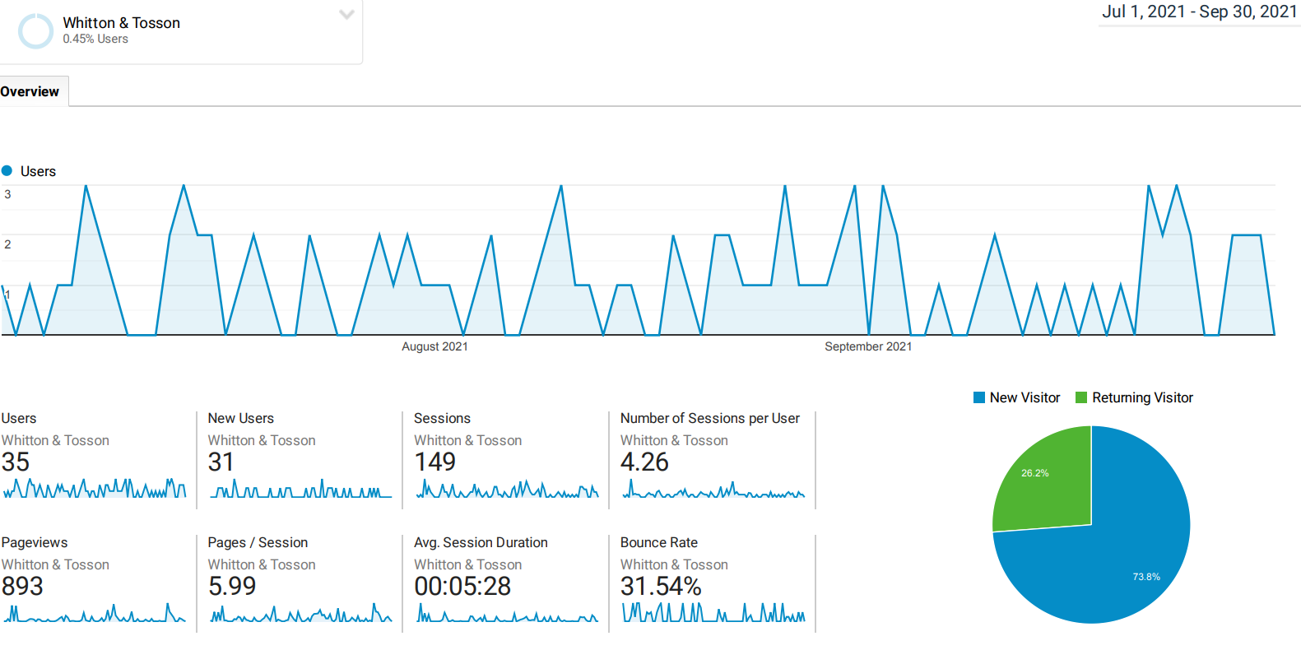
- Invitation to join the Town & Country Planning Association (TCPA). Members agreed not to subscribe to the TCPA.
- Free resources for people with dementia and their families. Playlists for Life work with around 1500 very diverse organisations throughout the UK (including Parish, Town and City councils and, most recently, all of Northumberland Libraries). Playlist for Life and personal playlists can help transform the lives of people living with dementia and disability, and those who care for them. Further information at: https://www.youtube.com/watch?v=VMSaqD3ArHw. It was agreed to place this link at the Parish Council Webpage and Facebook Page. HD to contact Tom Burwood regarding the management of our Facebook page. Action HD/Clerk
- Any Other Business
- Members were reminded that the Budget and Precept request would be agreed at the next meeting. They were minded to transfer a further £500 into the Business Savers account towards the reserve for election fees.
- Date of and Venue for next meeting: Thursday, 13th January 2022 at 7.00 p.m. in the Parish Rooms, Rothbury

Garth Rhodes, Parish Clerk, 5 Wardle Terrace, Longframlington, NE65 8AB
Tel: 01665 570347 Email: whittonandtossonparishcouncil@gmail.com

