The Burn Field Village Green
Cycle Track
Back in 2019 the Village Green Working Group were approached by local children who asked if the cycle track could be re-developed. The children were, in fact, trying to tidy it up themselves in order that they could use it. The working group brought this request to the attention of The Council and Leisure Centre (custodian trustees and owners). The Council was also informed, by Claire Heaviside, that there was an amount of money left over from the original work that was ringfenced for maintenance or improvement of the track. It was agreed to draw up a specification and advertise for contractors. The Leisure Centre applied for funding from the Northumberland County Council Community Chest fund and The Council agreed to pay the balance.
Tenders were sought in the summer of 2021 and a local contractor, Steven Ferguson, was chosen to undertake the work. The track was completed in the autumn and has proved very popular.
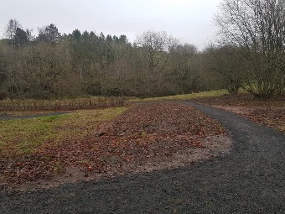
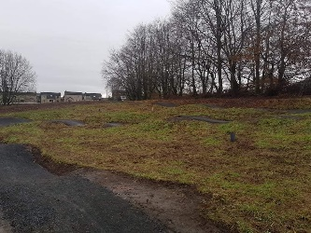
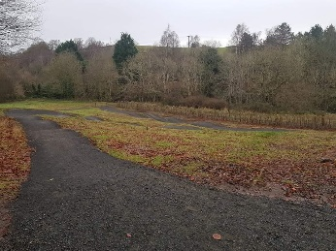
A new bin has been placed near the track to encourage littler picking and there are dog bin bag dispensers at 2 entrances to the green. The Council have arranged ongoing maintenance as part of their grounds contract and there will be a weekly inspection/litter pick of the track. However, it is requested that dog owners PLEASE use the facilities provided for their dogs and leave both the cycle track, and football area free from dog mess.
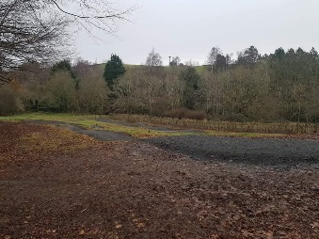
Football Field
The Jubilee club have recently moved leagues and as a result need to have spectator barriers for their matched. An S38 application was made to The Secretary of State to request permission for this work on a village green and was recently approved. Grant funding by the club was sought and the barriers purchased. match on. The whole of the Green is open to everyone for recreation. But it is requested that visitors please stay behind the safety barriers when a match is in progress.

Queen’s Jubilee Trees
As part of the green canopy for the Jubilee, trees have been planted at the north part of the green including cherry and rowan.

