**Ukraine War**

Members of Haltwhistle Town Council would like to express their full support and solidarity to the Ukrainian people and their peers in local and regional government.

On behalf of the town, a modest donation of £100 was made to the Disaster Emergency Fund.

**Memorial Gardens**

The covid memorial stone has been situated. The Council would like to thank Northumbria Stone Products for donation of the stone, Ian Robinson for making it and the cemetery staff for siting it. Thanks also go to Cllr Graham Ridley and Mr Mike McGuire who worked together on the wording.

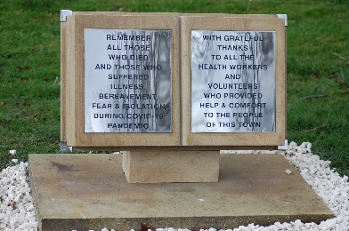

**Westlands Play Area**

Three new pieces of equipment have now been fitted at Westlands. The old climbing frame has been replaced by a new one, designed for under 6 along with two spinning pieces.

**Saturday Surgery**

The Council will resume their quarterly surgeries with 2 members in attendance. They are on May 28th, Sept 3rd and Dec 3rd 2022. They are held in the Old Estate Office with tea and coffee.

**Burn Field Village Green**

The spectator barriers are now in place around the football field. The green is for everyone to use and when there are no matches taking place, the football area can be used.

**Orchard Gardens**

The council have received an asset transfer of 4 parcels of land at Orchard Gardens from the builders, Linden Homes. They include the two flower beds at the front, a piece of grass on the right-hand side that is open land and an enclosed area of ground on the left-hand side.

The council will formulate a maintenance plan and consider how to improve the fenced off land.

**The Queen’s Platinum Jubilee Celebrations**

There is an enthusiastic working group preparing a section of events for the month of May concluding at the Jubilee weekend (2nd – 5th June). A programme of events and Face Book page will be set up/distributed over the next few weeks with information and, to encourage volunteers to help over the actual weekend.