Minutes of the PARISH COUNCIL MEETING
7.00 p.m. Thursday 13th July 2023
Parish Rooms, Rothbury

Present: Hilary Dunn (HD -Chair), Peter Henry (PH), Fran Tait (FT), Alan Tait (AT),
In attendance: Clerk: Garth Rhodes.

The meeting opened at 7.06 p.m.
- Apologies for absence. None
- Minutes of the meeting held on the Thursday 18th May 2023 were reviewed, unanimously approved as a true record and signed as such (proposed FT, seconded (AT), All in Favour).
- Matters arising from the minutes including:
- Simonside & Forestry England. Nothing further had been received.
- Thropton Spar Garage Lighting. Nothing further had been received.
- Replacement Seat: Whitton Bank. The seat had now been repaired and arrangements for the formation of the concrete plinth were underway. Action AT/PH
- Invasive plants along streams and rivers: Northumberland Rivers Trust Project. The only invasive plants were some Japanese knotweed on the Hepple side of the bridge which had been treated several years ago. No further action agreed at this time.
- Highways and Footways Report.
- The Footpath signpost to the Hill Fort and Simonside located at Great Tosson had now been replaced.
- The pothole at Tommy’s Lonnen on Carterside Road had been repaired. This had been reported using the new ‘Fix My Street’ app and had worked very successfully.
- The grips at Tosson Bank needed attention. Agreed that potential blockages should be reported in advance of them becoming fully blocked. Action: AT
- Police Report. There had been no crimes reported in the Whitton & Tosson area between 15/05/23 – 07/07/23 which would have a wider community impact. Officers would continue to provide enhanced, visible patrols in the village. Members were pleased to note that there was an obvious increased police presence in the parish and that the Fire Service had been providing advice to walkers at the Lordenshaw Car Park regarding fire safety.
- Finance
- Notification of receipts since the last meeting. None.
- Approval of Clerk’s salary, expenses, PAYE & NI and approval of Other Payments since the last meeting. Approved.
20/05/2023 | Rothbury DCC | Parish Church Room Hire | 12.00
24/05/2023 | Coquetdale Squirrel Group | Donation | 25.00
01/07/2023 | G Rhodes | Pay & Expenses (Apr-Jun)) | 259.52
01/07/2023 | HMRC | PAYE (Apr-Jun) | 61.00
 |  | Total | 357.52

- Requests for donations.
  - Defibrillator at Community Workshop, Ryehill Farmhouse. League of friends had agreed to fund the remaining amount for this and so the WTPC donation was not needed.
  - Citizens Advice Northumberland. Donation of £25 was approved
- Bank Reconciliation. Approved.
 | Bank Reconciliation 10th July 2023 |  |  | £
Balance per bank statements | Community account |  |  | 2364.67
at 31st May 2023 | Business Saver |  |  | 2011.65
 |  |  |  | 4376.32
Less unpresented payments | 01/07/2023 | G Rhodes | 259.52
Parish Council | 01/07/2023 | HMRC | 61.00
 |  |  |  | 320.52
Uncredited Deposits |  |  |  | 0.00
Balance 31/05/2023 |  |  |  | 4055.80
Balance per cash book |  |  |  | 4055.80
- Planning: There were currently no requests for consultation that had not already been commented on.
- Rothbury JBC Report Jeff Sutton had been appointed as Chair. The issue regarding the diversion of the stream was in abeyance due to the sale of the Rothbury estate. Land available for burials for at least 10 -12 yrs. The Internal Audit for the JBC had been approved.
- Coquetdale Cluster Report. There had been an excellent turn-out for the meeting with Anne-Marie Trevelyan (AMT) MP to consider the analogue telephone switchover. She noted the issue of the need for support for those vulnerable people without internet connections and their need for a battery back-up system to enable their phones to work during an outage. The meeting had also discussed the proposal for a new swimming pool in Rothbury. AMT was unaware of this and agreed to look into the issue.
- Tree Planting Update . The 2023 report was warmly received by members at our meeting. They were much impressed with the detail and the extent of planting that has been achieved. Thanks to Alan Winlow and all concerned.
- To agree arrangements for the formal presentation of the Freedom of the Parish
- Venue & hospitality. The Cheviot Room in the Jubilee Hall had been booked from 4 – 7 p.m. on Monday 11th September for the event. The Running Fox buffet was approved. Action: FT/Clerk
- Programme for the event. The Programme and Guest List was finalised. The Clerk to draft an invitation for email approval by members. Action: Clerk
- The following programme was agreed
  - Opening 5.00 p.m. :
  - Welcome
  - Overview of the Freedom of the Parish
  - The Nominations
  - The Award of Freedom of the Parish
  - Light Refreshments
- The Parish Council Logo and arrangements and detail for the framed scroll were approved. Action: Clerk
- Arrangements for a “Roll of Honorary Freemen and Freewomen of the Parish of Witton & Tosson ” to be placed on the Parish Website, was agreed. Action: Clerk
- Publicity on parish council website and elsewhere. To be published in ‘Over the Bridges’ and possibly more widely in the local press after the event? Action: Clerk
- Arrangements for Photographs was agreed. Action: HD
- Local Transport Plan Capital Programme 2024-25 LTP. No priorities were identified and no further action agreed.
- Request from Rothbury CAN for Coquetdale Cluster Climate Change Action Plan. The members discussed a proposal for a Coquetdale Climate Action Plan. The unanimous response was in favour of such a proposal. HD agreed to represent the Council on this matter. The issue of whether the Coquetdale Cluster Group of Parish Councils was likely to support/be the co-ordinating body for such a venture was also discussed. All were agreed if it was not, then our Council would still be in favour of being part of a Coquetadale Action Plan initiative. Action: HD/Clerk
- Whitton and Tosson Parish Council Website - Quarterly Report
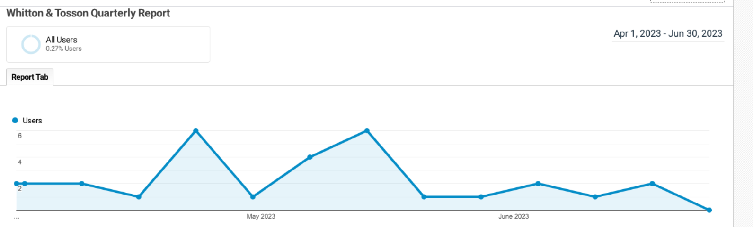
- Any Other Business
- Request for Rothbury Estate to be listed as Community Asset). (Appendix 7) The members discussed the issue of the sale of the Rothbury Estate. It was agreed that, at the present time, they would not be taking this issue further and would not be calling an extraordinary meeting to discuss a submission for nominating the estate as a community asset.
- Changes to the NCC North Local Area Committee (LAC). (Appendix 8) New ways that the committee would do business was announced. The LAC is a key vehicle by which Parish & Local Councils consult on planning, highways and local services matters and most importantly considers planning applications for the North of the County.
- Date and Items for the next Parish Council Meeting: Thursday 21 September 2023 at 7.00 p.m. in the Parish Rooms, Rothbury.
There being no further business the meeting closed at 8.10 p.m.

Garth Rhodes, Parish Clerk, 5 Wardle Terrace, Longframlington, NE65 8AB
Tel: 01665 570347 Email: whittonandtossonparishcouncil@gmail.com

