Notes of the Brinkburn & Hesleyhurst Parish Climate Change & Biodiversity Steering Committee

Meeting on: 18th October 2023
Meeting at: Longframlington Memorial Hall
Meeting Time: 7.30 p.m.
Present: Cllrs: Judith Baker (JB), Roger Powell (RP), Jackie Scarpa (JS), Jen Teulon (JT) Jamie Whicker (JW) – Chair,
In attendance: Clerk: Garth Rhodes.

Note: These brief notes are intended to record the main issues discussed and decisions agreed. They are not intended to provide a verbatim record of the meeting. Detailed Strand/Project reports will be found in the appendices.
Meeting opened at 7.33 p.m.

- Apologies Des Barker (DB), Mark Fenwick (MF); Davod Owen (DO) Patricia Welsh (PW) Sue Whicker (SW)
- Notes of Previous Meeting held on Monday 31st August 2023 were agreed.
- Matters arising not appearing in the agenda. None
- Update on current applications to Wingates Windfarm Community Fund (WWCF).
  - The following funded projects were now complete and final reports had been submitted to WWCF
    - WWCF 102 - Playing field fence and barrier (not strictly one of our projects but related to our work
    - WWCF 101- Information Event
  - Projects recently approved:
    - WWCF 107 Playing field pilot hedge laying project
    - WWCF 108 Nest Box Scheme
    - WWCF 109 Geographic biodiversity database
- Financial Report. The following reports were received.
  - WWCF 102 - Playing field fence and barrier
Expenditure Incurred | Invoice Detail | Invoice Value Total (Gross)  £ | VAT  £ | Total (Net)  £
Capital Items i.e. equipment
Materials: Fence posts, rails, nails. | Northumberland Country Services 13th July 2023 | 313.56 | N/A
Revenue Items
Labour | Northumberland Country Services 13th July 2023 | 240.00 | N/A
Total Expenditure £ |  | 553.56 | 92.26 | 461.30
Grant Awarded |  | 553.36
Less grant previously paid |  | 415.00
Total final payment |  | 46.30
Total Amount Claimed |  | 461.30*
*VAT not able to be claimed under grant as we claim back VAT from HM Revenue.
  - WWCF 101- Information Event
Expenditure Incurred | Invoice Detail | Invoice Value Total (Net) | VAT | Total (Gross)
Capital Items i.e. equipment (please list as per application form)
X1 Presentation Board | Boxes and Board International | 49.96 | 9.99 | 59.95
Revenue Items (please list as per application form)
120pcs Seed enveloped | Xinxiuying Technology | 4.74 | 0.95 | 5.69
Plastic Clipboard sets | Maxfind LLCInv …10232 | 17.40 | 3.48 | 20.88
Double-sided Glue Dots | Crafter’s Companion | 5.82 | 1.17 | 6.99
VRH Auctions | Fast Adhesive Spray | 11.68 | 2.33 | 13.99
Food for Event | Sainsbury 3539954-46F74F | 218.40 | 0.00 | 218.40
Soft drinks for Event | Sainsbury 755601569 | 89.60 | 0.00 | 89.60
Supply of Meadow Seed | B& K Wharf Farming | 50.00 | 10.00 | 60.00
B K Barker | Logo design | 25.00 | 0.00 | 25.00
Total Expenditure £ |  | 472.60 | 27.92 | 500.50
Grant Awarded |  | £455.00
Less grant previously paid |  | £341.00
Total final payment to claim |  | £114.00
Expenditure above the Grant |  | £17.60

  - WWCF 107 Playing field pilot hedge laying project
Project costs | £
Hedge laying appx 81 metres in the midland style. Labour @ 21.50 pm | 1701
Materials 180 stakes @ 90p per stake | 162
200 binders @ 90p per binder | 180
Training days @ £300 per day x 3 days | 900
Toilet hire (estimated cost) | 300
Chipper hire | 280
Marquee hire from Simonside country fair | FOC
Marquee insurance (estimated cost) | 280
Internal small wire fence removal and disposal | 250
Project total | 4053
Total Grant Approved | 4053
Grant Paid to date | 3034
Expenditure to date | 0
  - WWCF 108 Nest Box Scheme
Project costs | £
46x (6inch x 5/8th x 8 foot long boards) | 110.40
3x (8inch x 1 inch 8 foot long boards) | 15
9 litres Ronseal wood preserver (3 coats) | 22
Labour for construction and painting :50 hours @ £12.50 | 625
Stainless steel screws 4mm x 30mm x 2 packs @ £17 | 34
5mm x 80mm x 2 packs @ £22 | 44
6mm x 130mm x 1 pack @£55 | 55
Wood glue: Evostick 1 ltr | 13
Core drills 28mm, 32mm, 35mm Erbauer set | 40
Labour for erecting the boxes along the Lee and Maglin Burns | 200
Project total | 1158.00
Total Grant Approved | 1158
Grant Received to date | 868
Expenditure to date | 326.83
  - WWCF 109 Geographic biodiversity database
Project costs | £
Panasonic Toughbook FZ-Gmk 3 | 585.98
QGIS geographic information system software | FOC
Project total | 585.98
Total Grant Approved | 585.98
Grant Received to date | 440
Expenditure to date | 0
  - Issues concerning Purchasing, Invoicing and Tendering. There had been a numbering of teething problems that had come to light with respect to the finances of the project. It was confirmed that:
    - VAT Should not be included in grant applications as we reclaim VAT from HM Revenue.
    - Orders/Tenders. Orders for values from £500 to £2000 required a minimum of two quotations. Clerk was investigating whether it was possible for the lower threshold level to be increased. We must be very careful in the way we agreed and awarded work, as all money was considered to be public once this came into the PC account. All orders and contracts which required quotations would need approval by the Council. Order arrangements to be discussed with Clerk prior to purchase. While the Council was not obliged to accept the lowest quotation the reasons for accepting the quotation would need to be justified and recorded. Where work was to be carried out by a member of the council/committee it must be demonstrated that the work had been awarded fairly and without favour. Whilst there had been no conscious breaches of procedures it was important that as a public body, we were seen to carry out our financial procedures in a wholly correct manner. The Committee must adhere to the regulations set down in the Parish Council’s Standing Orders.
    - Submission of Documentation. In order to ensure that a record and audit trail was kept centrally, and all procedures carried out correctly, official documentation including grant applications/ orders/grant reports to be submitted through and by the Clerk. In order not to cause delay, deadlines needed to be adhered to.
  - Clerk’s Workload. The committee were concerned that the 2 hrs per month paid to the Clerk for CC& B Committee work agreed by the Parish Council was inadequate, as it was evident that he was currently working significantly more hours on this work. JW to present the issue to the PC at its next meeting in November. Clerk to log hours of work in the interim Action: JW/Clerk

- Strand & Project Reports

Strand/Focus | Project | Issues/Actions Agreed
- Recognition and maintenance of the scenic beauty of the landscape | Litter Picking Programme Appendix 1  Project Lead: Patricia Welsh | Due to roadworks on B6334 it was agreed litter picking here at present was not required. JW to speak to PW re alternative site
- Wild-Flower Areas | - Wild Flower Meadows/areas Appendix 2  Project Lead: Jackie Scarpa  - Extended Habitat Survey. Appendix 3  Project Lead: Judith Baker | B& K Wharf Farming had been very generous with supply of wild seed and there was a significant amount available for those people who wanted to establish a wild flower area.  Record of those to whom seed was distributed to be kept and they be asked to keep photographic record and ask to contribute to bailing the hay at end of season. JW agreed to build hand bailer. Participants to be informed through WhatsApp.  Flower displays of native species to the area in first years may not be spectacular. Additional bright flowers seed to be considered.  It was agreed that as a gesture of goodwill, seed would be made available to those who had attended the WFGA training event.  Action: JS/JW  Agreed in principle to purchase of refurbished Panasonic Toughpad FZ-G1 mk 3 with retro installation of Windows 11 as this would meet the required specification and was within budget. Detailed rationale for the purchase and purchasing arrangements to be submitted to Clerk. Action: JB
- Improving Biodiversity | Playing Field Pilot hedge laying project Appendix 4  Project Lead: Jamie Whicker | Hedge laying had begun. 17 people signed up to the training programme. Dates for the training had not yet been set. David Boyson. Hedge layer/trainer, had confirmed that insurance/ first aid/equipment arrangements for the training were covered.
- Partnership Working/Improve Organic Landscape | Meetings/developments with land owners to outline plans and to seek permission to develop/regain an organic landscape. Appendix 4a & Appendix 4b  Project Lead: Roger Powell Jamie Whicker | Agreed that this was a long-term project which required sensitivity. There was supportive government legislation e.g. Farming Rules for Water which may help in discussions. The start was building the relationship with farmers/landowners and to get their permissions and to get them engaged with the agenda through building on the positives. The habitat survey would help in this as it would provide evidence for improvements and be useful to help develop and obtain funding for land management schemes. It was estimated that we would have significant data within 18mths – 2 yrs. to assist landowners/farmers.
- River Coquet Ecology | Monitoring and maintenance of the River Coquet and its immediate environment Appendix 5  Project Lead: Mark Fenwick | Recent meetings with SNAC and Steve Low (Northumberland Rivers Trust) showed that there was already a significant body of evidence and activity along the river and it was important that the CC&B dovetailed into this. It was important that this was followed up prior to engagement with Newcastle University. Action: JD/MF
- Enhance bird breeding populations | Nest Box building programme Appendix 6  Project Lead: Roger Powell | Construction and painting of bird boxes almost complete. JW and RP to follow up on landowner permission and discussion to take place with local gamekeepers for their support for the erection of the boxes in the areas of Maglan Burn & Forest Burn. Action: JW/RP

- To discuss how to proceed with the proposed the three areas identified by BHPC for potential biodiversity projects (Nature Recovery Networks) and in particular the instigation of discussion with the relevant landowners on these matters:
  - The Disused Railway line through the Parish as a biodiversity corridor and public right of way.
  - Biodiversity/ Rewilding Corridor linking Hepple Wilds and Thistleyhaugh Estate (in conjunction with other PCs).
  - Wards Hill with a particular emphasis on the improvement of the organic landscape and the protection of our fauna and flora.
It was agreed that the Partnership Working/Improve Organic Landscape Strand (6d) take on this agenda and develop a proposed strategy for the five-year action plan for discussion at the next meeting. The baseline habitat survey (6b ii) would provide valuable information to take forward discussions with landowners. The issue of who owned and had access to data gathered in particular areas during the survey was discussed. It was agreed that this would need to be agreed with the respective landowners prior to data gathering. Action: JW/RP/JB
- To receive report and discuss matters in relation to Communications & Media. See Appendix 7
- To discuss issues with respect to the use of Volunteers. As we move to implement our projects and call on volunteers to assist it was important that we develop procedures and documentation to keep informed and safeguard those who volunteer. Clerk had begun to explore content of a volunteer handbook, registration documents, insurance and disclaimers. This was too much work for him alone. It was agreed to look around for a suitable person to take on the role as volunteer co-ordinator to work alongside Clerk and to obtain advice from the Northumberland Network/ other organisations. Clerk reported that he had written to the Conservation Volunteers to ask if it would be possible to affiliate to them. Action: JW/JB
It was agreed that we could call upon experts and volunteers from outside the parish, but that it was important to ascertain that their intentions and values met with those of the CC&B.
- To receive report on the North Northumberland Environmental Network. JB . See Appendix 8. Members welcomed the idea of working with the Network to share information and expertise but agreed that we maintained our focus on our five-year plan and not get involved in any non-violent civil disobedience activity that might emanate through the network.
- To discuss how the Committee continues to manage and monitor all its commitments and ensure that it does not overextend its activities. With the growing list of projects and activities the PC was concerned that the Committee and volunteers do not extend themselves. Agreed that no further projects to be considered at the present time and Strand leads to re-visit their elements of the 5-yr plan to ensure a realistic programme of action.
- Any Other Business.
  - Request from Rothbury Parish Council: JW agreed to attend a future RPC meeting to advise/inform them about our Climate Change Plan and bio-diversity projects? Action: JW
  - Coquetdale Climate Action Group: Katie Scott had sent out a last call to Parishes to ask if they wanted to take part. Parishes that had responded positively to date were: Whitton and Tosson, Rothbury, Brinkburn and Hesleyhurst, Thropton. JT and JW agreed to represent the CC&B committee and JB agreed to act as stand-in.
- Date of Next Meeting: Wednesday 13th December at 7.30 p.m. in the Longframlington Memorial Hall

Meeting closed at 9.30 p.m.

Garth Rhodes, Clerk, 5 Wardle Terrace, Longframlington, NE65 8AB,
Tel: 01665 570347
Email: Clerk@Brinkburn.net

Appendix 1

Appendix 2
Wildflower Meadow Project Update
Jackie Scarpa

Sowing our wildflower meadows
Kevin Wharf of Burradon Windyside Farm has given us 3kg of his wildflower meadow seed. This seed was purchased with money given by the Wind farm fund. We were hoping to buy 1kg (commercial rates) but Kevin generously gave us three times that!
At the moment the seed is being distributed to all who requested it at the Biodiversity event and to anyone else who finds they have a patch of garden they might devote to a wildflower experiment.
Data will be collected throughout the season to monitor the amount of seed distributed and applied, as well as area seeded and yield given, both in terms of volume and diversity of species. Reports of insect activity will also be welcome. Not everyone will have the time or inclination to monitor their plot at all stages, but we will be able to provide valuable estimates based on the area coverage of the data that we do receive. This will allow us to extend this project beyond its initial mandate (of increasing biodiversity and improving wellbeing of residents and visitors) to include a carbon sequestration indicator.
I am planning to set up a WhatsApp group for ‘Meadowmakers’ so we can keep in touch and share information and stories over the course of the project.
Des and Brenda have worked hard to scout out the parish verges and waysides over the summer, eventually producing a map with 3 - 4 possible sites that showed most promise. Brenda also made plant species inventories for several stretches of roadside verge near the Terrace.
Kevin came out for a site visit and approved these verge choices, giving valuable advice about how to proceed without overextending ourselves.
We are presently contacting and liaising with adjacent landowners of these sites and the Council to decide on how much to include in this year’s sowing.
In September Judith and I attended a workshop in Alnwick (organised by the North Northumberland Environmental Network) intended to bring together all those who are concerned about the local environment and working to help local communities. The result of this workshop was to create a WhatsApp group within which a number of interest groups can share information and resources to enable everyone to make a bigger impact and receive encouragement and expertise. Hopefully this will help those starting new endeavours to benefit from work already done and not have to fumble their way through alone. People were particularly interested in advice on insurance, liabilities and finding funding for projects. Most of the attendees were retired professionals from a range of backgrounds which meant that there was an interesting variety of ideas and approaches that came up in discussions.
On Thursday 18th October I am taking part in a workshop teaching how to create a Wildflower garden. This is being offered by the WFGA (Working For Gardeners Association)
And is run by a horticulturalist who has worked with Durham Council to convert council-maintained verges into wildflower meadows. I am hoping pick up useful information about how to work successfully with council officials as well as the practical challenges involved in such an undertaking. Hopefully there will be plenty of likeminded people there who will broaden our network of useful contacts!

Appendix 3
BHPC Climate Change and Biodiversity Group Habitat Survey
Introducing the Extended Habitat Survey
The purpose of this information sheet is to introduce the desk study for our extended habitat survey so that members and others can consider whether they wish to be involved in it. There are a number of standard information sets that are required, and these can be done by different individuals or groups of people as you wish. I pose some questions at the bottom of the page which we need to discuss. You may have other questions. There are standard sources of information which will be detailed once we have established who is doing the work, there isn’t room for it here!
What is an extended habitat survey?
An extended habitat survey is a study that investigates the baseline ecological value of an area or, more commonly, a development site. The study will look at the habitats within the target area’s boundary, and their potential to support protected species. This type of survey is often also called a Protected Species Assessment (PEA) and informs the decision on what other surveys are necessary to support a planning application. In the context of our group’s aims, we are not thinking in terms of development, rather in terms of habitat protection, enhancement, and creation. All the same, we still need to understand our baseline so that we don’t inadvertently damage it, and are better placed to strategically protect it, enhance it and create new habitats which will increase the biodiversity value of the parish. Farmers applying for land management schemes may find the results of the survey useful, and it may lead to significant ‘joined up thinking’ in land management across the parish. If there is development proposed within the parish, it will provide a valuable resource for the parish council when they are assessing the planning application.
Stages of an extended habitat survey
1. Desk study
A desk study provides a baseline for the extended habitat survey. It will cover the following:
‘Site’ information (i.e. parish location) – location, boundaries, setting within the landscape. Designated Site Information – identification of any designated wildlife sites within the parish, these may be statutory or non-statutory. Data on the location of each designated site, it’s boundary and reasons for designation will be recorded. Species records – existing records indicating the presence of protected species or priority species within the parish will be collated. This is important so that we don’t overlook potential of habitats in the parish, even if there are no clear signs of protected or priority species using them at present. I propose that we extend this section to any species records for the parish, there are some sets available for some farms. Habitat information – existing information on the habitats within the parish and immediately adjacent to it, in broad terms. Distribution information – contextual information, i.e. distribution maps) of any protected or priority species in the locality.
2. Field Survey and 3. Report – details to follow.
Questions:
- Who will ‘own’ the completed survey, and who will have access to it? This needs to be established before we ask landowners for permission to survey.
- Who can be involved in the survey? We have some expertise within our group covering plants and birds. Can people from outside the parish join in (we have potential interest from a retired behavioural ecologist ref. mammals, and a botanist)?

Appendix 4a
Appendix 4b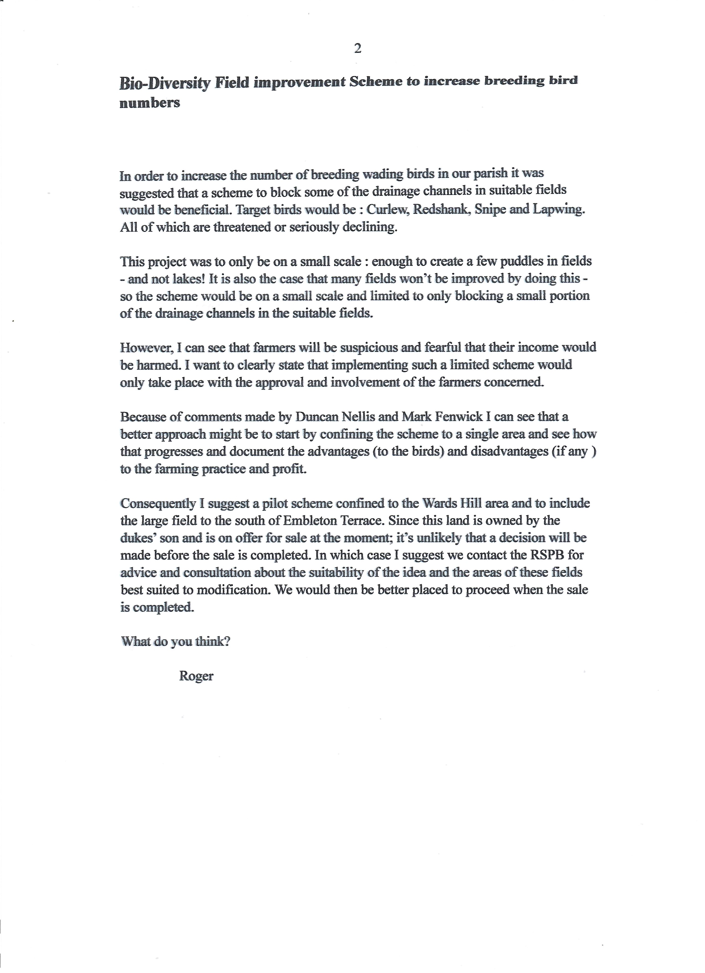
Appendix 5

Update in recent activity: Water Quality Theme

I met with Dr Claire Walsh at Newcastle university. You can understand her research base here https://www.ncl.ac.uk/engineering/staff/profile/clairewalsh.html
The purpose of the meeting was to identify the opportunities there might be for the monitoring of water quality of the Coquet river in the Brinkburn and Hesleyhurst Parish.
Further to this we discussed the projects for water improvement that had been identified by the River Restoration Centre;

• Baseline water monitoring
• Enhancing Outfalls to River
• Providing Livestock Access :Stock Watering Points
• Improving Channel Morphology
• Black Burn , Forest Burn, Todd Burn, Maglin Burn
• Creating floodplain wetland features
Dr Walsh was firstly interested in the landownership. I explained that there were farmers practicing regenerative farming through which the Todd Burn ran. The Rothbury Estate owned the majority of the Forest Burn. The Rothbury estate was currently on the open market as Carbon Capture project. The Black Burn ran partly through National Trust Land and Crag End farm owned by the Chair of the Northumberland rivers Trust. It would appear to me that all of these streams would potentially be running through land owners who were open to a water-based improvement.
I briefly explained the other biodiversity projects and funding which had come from the Wingates Windfarm Fund.
Dr Walsh felt that there was an opportunity to utilise some of the PHD and Master students she supervised to help identify the baseline monitoring data we would need to understand any issues along the water courses. She was also interested in the wider project and would like to understand whatever baseline data we were collection and how it was being captured. She felt that there may be an opportunity for wider academic departments to become involved.
Her first thought was to propose a field study trip to the parish and a walk through the various environments. She was suggesting a date in November with the aim of starting some research projects for January 2024.

Appendix 6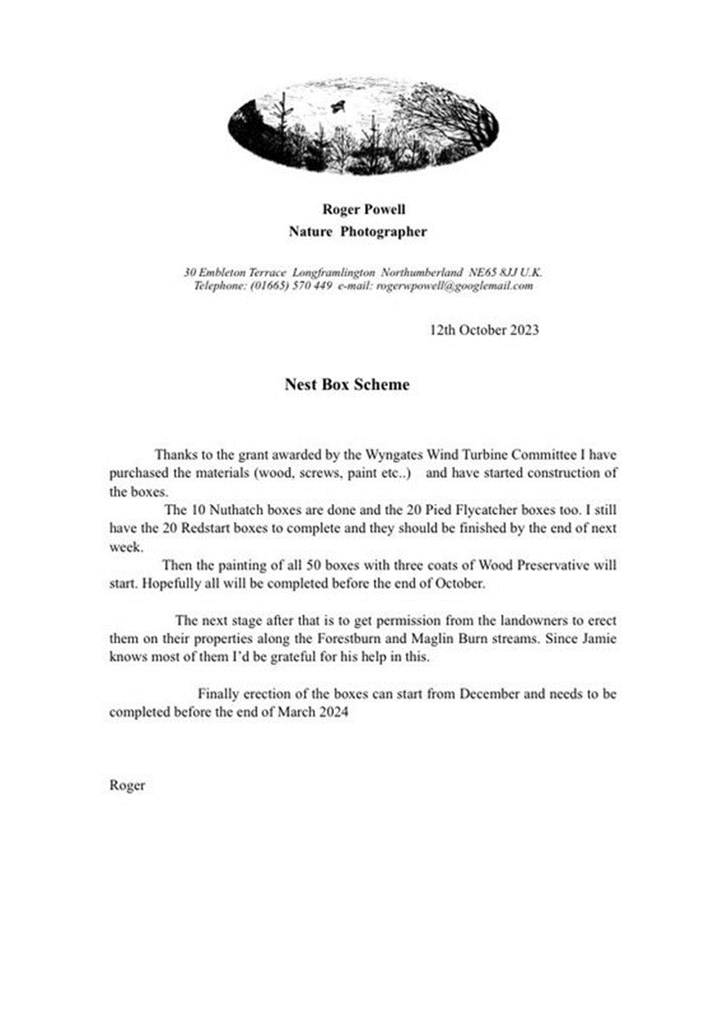

Appendix 7 Communications & Media Report.

I printed off approximately 90 Newsletters which were distributed around the parish over a 2 day period. Whilst out delivering I got to speak to a number of residents to explain what I was giving them.
Judith assisted me in delivering the Newsletters door to door.
The Newsletter outlined the group purpose, members and a report sent in by Judith .
End of report.

Appendix 8 North Northumberland Environmental Network Workshop 23 September 2023
Summary of discussion
Introduction
This workshop was organised to discuss and agree how a ‘loose structure to facilitate communication and collaboration’ between the numerous environmental grassroots organisations in north Northumberland would work in practice.
Following a meeting in Autumn 2022 a Planning Team was formed to take the idea of a network forward. For this 2023 workshop they invited local ‘green’ organisations to attend, not including established NGOs such as The Wildlife Trust who were present last year. A list of who was present, the organisations they represent and the focus of their work is appended below.
After introducing the Planning Team of Lesley Long (SNAC), Liz Clark (SNAC), Mike Powell (Alnwick Friends of the Earth) and Julia (sorry, no surname) (Warkworth Green Matters), the background to the event was given. The Planning Team have drawn up a list of projects that are being done and will email it out shortly. They identified a number of common issues for discussion:
- banks, setting up groups, insurance
- getting farmers involved – how
- nimbyism
- identifying things that we can do things about
- funding
- engaging people
Going forward possibilities:
- help physically with events
- tackle projects more effectively through joined-up work
- funding
- dealing with farmers (engaging, permissions)
- stronger representation on NCC
Group discussions
The group was then split into four groups of 5 or 6 to discuss responses to two questions:
- What do you want from a Network?
- How to structure/deliver the Network?
Following a break there was a feedback session and discussion of the main points raised by each group, as follows:
- What do you want from a Network?
Publicity
Information sharing – what are others doing, sharing expertise (fundraising, setting up groups, charitable status, projects etc)
Contacts – who is where with what skills and interests
Speakers – who from other groups could speak at meetings or events
Form a critical mass for representation, e.g. to Northumberland County Council or even nationally
Pressure group
Be an inspiration – internally and externally
New ideas
Regular meetings
Mutual Support
Representation on NCC Environmental Forum
Electronic information sharing
Celebrating each other’s successes
Support each other and links to other groups
Links to supermarkets (for food banks)
NCC Climate Champions network
Identify areas without groups to extend publicity to
Promoting issues e.g. through parish clerks
Share NCC’s funding information
Have a themed meeting
Environmental hustings for general election
Lobbying
Knowing who has what data
Knowing the right language for your target group
See through greenwashing
What specialisms exist in each group at a personal level
Share good practice (Champions)
Training needs

- How to do it
Communication – newsletter – email – requires help and editorial
google drive
slack app
WhatsApp
Website
Issues to consider:
Editorial input required?
Who will drive it?
Meetings/workshops (frequency)?
Public facing role?
Community days
Do we need a closer link with NCC?
‘Specialist groups/links’
Locality of networks
Directory of our expertise
Obstacles to consider:
Over-inundation of emails
Email fatigue
Lot of talking prevents action
Over complication – too much dilution?

Comment on the above
As you can see, there is a lot of overlap in the answers to 1). I got the impression that most people were simply seeking the opportunity to link up with other groups to share experiences/information/ideas/avoid duplication or to have the opportunity to request help in the form of expertise so that the wheel isn’t constantly reinvented, wasting resource, time and effort. i.e. networking in the true sense of communicating and helping each other out on occasion. There was a strong minority element of wanting to use the Network for campaigning, lobbying and political work (the upcoming general election was mentioned a few times). Quite a few points were made using examples of organisations, Extinction Rebellion was named a couple of times.

On 2 – How? the idea of a website wasn’t considered great, but then they are looking into it, so that is a bit confusing. Ali Elly spoke enthusiastically about using the SLACK app. Lesley Long and Liz Clark have already given this some thought, they felt that SLACK is good but takes some getting used to and maybe requires more technique that some are used to using. Facebook was a non-starter as so many people don’t like it now. Google drive wasn’t really discussed. People were concerned about being inundated with emails. Lesley and Liz had done some research into WhatsApp, Liz gave a short presentation on how it works using Communities and Groups.

The WhatsApp community provides an umbrella and up to 20 Administrators are allowed. Up to 5000 people can be members of a community, which is used for main announcements that apply to everyone. There is no option for members to chat to each other in the community page. The Groups sit underneath the Community, each group can have more than 1000 members (think family tree).

The groups can have a poll tool, emojis for quick responses (i.e. acknowledging a message), can share files up to 2GB, can share voice calls up to 32 people, and can be used for chatting.

Anyone having a mobile phone can join the community and multiple groups if desired. Potential groups are biodiversity, energy/warmer homes, climate, food banks etc to represent the overlapping interests of the group.

It was agreed that in the short-term WhatsApp would serve the Network’s needs and the Planning Team are going to set it up.

Projects and Opportunities for Network Members
Each participant wrote their focus on a post-it note and posted it on the board. Mike Powell will write this up, with notes of the meeting, to be circulated.

Group Name – What’s in a Name
A short discussion about a shorter snappier name ensued. Need to be careful of single words as may run into trouble when googling it. Acronyms can be difficult for people with cognitive difficulties and should be avoided if possible.

North Northumberland? – or do we want it to be the whole of Northumberland? Point made that it could be difficult to maintain capacity at a personal level if included whole of Northumberland.
Planning Team to take ideas forward.

Next Meeting – before Christmas, or possibly January.

Action:
- Planning Team compiling a directory
- Notes of meeting with projects – Mike Powell
- Group name – Planning Team
- WhatsApp Community and Groups – Planning Team

