Warden and Newbrough Flood Wardens Needed
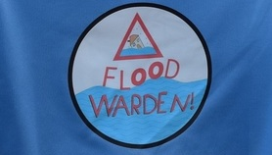
The Parish Council and the Environment Agency are calling on local people to play their part in the Warden and Newbrough Parish by registering to volunteer as a Flood Warden.
Flood Wardens are the eyes and ears on the ground before, during and after a flood event; they act as a link between the Environment Agency, Local Authority and communities at risk - getting vital information out to local residents.
The community is in the process of creating a robust contingency plan but needs people to volunteer their time to ensure that the plan can be used effectively in the event of a flood. This is not a time-consuming role, only requiring your support when flooding is possible and to ensure that the plan remains up to date.
Flood Warden Groups exist throughout the country to help communities be prepared for and resilient to potential flooding from rivers, the coast and surface water. North East wardens have a direct line through to the Environment Agency’s Area Incident Room in Newcastle.
Outside of a flood event, they can help raise awareness of flooding issues in the local community, encourage people to register to receive free flood warnings and provide information to partners about vulnerable people or properties in the flood plain.
If you are interested in volunteering please contact Colin Hall (Flood Resilience Engagement Officer) at engagement_northeast@environment-agency.gov.uk.

